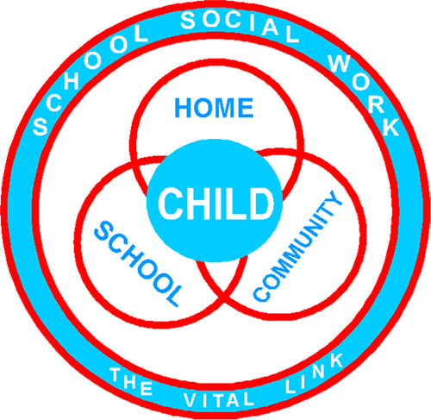

Your K-8 Social Worker

Jessica Woodson, BSW

Email: [woodsonj@in.halifax.k12.nc.us](mailto:woodsonj@in.halifax.k12.nc.us)

Phone: 252-445-5455 ext. 1513

If you feel that your family and/or student(s) could benefit from the services provided by your School Social Worker or you have questions/concerns—please do not hesitate to reach out. The contact information is listed below.

**Examples of Issues That May Prompt a Referral:**

* Food, clothing, and other basic needs
* Mental and behavioral health concerns
* Housing, rent, and utility assistance via community resource referral
* Change in academic performance
* Chronic absence and/ or tardiness issues
* Medical needs (hygiene, dental, etc.)
* Navigating government benefits (WIC, TANF, SNAP, and more)
* And more…

**What is a School Social Worker?**

School Social Workers are an integral link between school, home, and community in the effort to help students achieve academic and personal success. They work directly with school counselors and staff as well as students and families in the effort to eliminate barriers to learning. As a part of an interdisciplinary team to help students succeed, School Social Workers also facilitate community involvement in the schools while advocating for student success. School Social Workers offer a unique perspective in dreaming, planning, and setting the future stage for student success.

**SCHOOL SOCIAL WORK SERVICES**