Resources Provided by NC Department of Public Instruction (NCDPI):

Unpacking Document | EOG Test Specifications | NC Check-In 2.0 Information | Released EOG | Instructional framework | 3rd Grade Math Games
Quick Reference Guide for NC Standard Course of Study |  | NC Standard Course of Study (3rd grade math only) | complete Sample Lesson Plan | SAMPLE LESSON TEMPLATE DAY 1 | DAY 2 SAMPLE LESSON PLAN

Additional Resources:

DESMOS Embed Code | Tools4NCTeachers | https://www.k5learning.com
Kahoot Game | CommonCore Worksheets - Many of these resources may be in alignment with the current  NC Standard Course of Study, but please be sure to utilize ONLY those in direct alignment to the NCSCOS.

School Year at a Glance:

Domain/Cluster/Strand | Standards
 | 1st Nine Weeks | 2nd Nine Weeks | 3rd Nine Weeks | 4th Nine Weeks
1) Building Mathematical Community & Understanding Equal Groups | NC.3.OA.1, NC.3. NBT.2  NC.3.OA.2, NC.3.OA.9
2) Using Data to Solve Problems | NC.3.MD.3, NC.3.NBT.2, NC.3.OA. 8
3) Stories with Addition  and Subtraction | NC.3.NBT.2, NC.3.OA.8 | NC.3.NBT.2, NC.3.OA.8
4) Making Sense of Multiplication and Division |  | NC.3.OA.1, NC.3.OA.3, NC.3.OA.6, NC3.OA.7, NC.3.OA.8, NC.3.OA.9, NC.3.NBT.3
5) Reasoning with Shapes and their Attributes |  |  | NC.3. G.1
6) Applying Operations to Area and Perimeter |  |  | NC.3.MD.5, NC.3.MD.7, NC.3.MD.8
7) Understanding Fractions as Parts of a Whole |  |  | NC.3.NF.1, NC.3.NF.2, NC.3.NF.3, NC.3.NF.4 | NC.3.NF.1, NC.3.NF.2, NC.3.NF.3, NC.3.NF.4
8) Using Tools to Measure Length, Weight, and Capacity |  |  |  | NC.3.MD.2
9) Understanding Time |  |  |  | MC.3.MD.1
NC Check-In 2.0 Information | *NC.3.0A.1 *NC.3.OA.2, *NC.3.OA.9 *NC.3.NBT.2 *NC.3.MD.3 | *NC.2.OA.3 *NC.3.OA.8 *NC.3.NBT.3 *NC.3.MD.7  *NC.3.MD.8 | *NC.3.OA.8 *NC.3.NF.2 *NC.3.NF.3 *NC.NF.4 *NC3.G.1

Unit/Module Pacing: 1st Nine Weeks/Quarter 1 (45 days)

Number  of Days | Name of Unit/Module | Prerequisites | Standards | Academic Vocabulary | Instructional Resources
15 - 20  days | 1.Building Mathematical Community & Understanding Equal Groups | NC.2.OA.3  NC.2.NBT.2 NC.2.OA.4 | NC.3.OA.1  NC.3.OA.2  NC.3.OA.9  NC.3. MD.3 | equal groups, multiplication,  strategy, repeated addition,  skip counting, even, multiple  odd, error, array, division,bar graph, data, question, picture graph, scale, data collection, frequency table, category, represent, (How many fewer?,  How many more?) | Cluster 1 Resources from Tools 4 Teachers
5 - 10  days | 2. Using Data to Solve Problems | NC.2.NBT.7  NC.2.NBT.8  NC.2.OA.1  NC.2.MD.8  NC.2.MD.10  NC.2.NBT.5 | NC.3.MD.3  NC.3.NBT.2  NC.3.OA. 8 | Add, subtract,two step, bar graph, data, question, picture graph, scale, data collection, frequency table, category, represent,  How many fewer?,  How many more? | Cluster 2 Resources from Tools 4 Teachers
10 - 15  days | 3. Stories with Addition and Subtraction (Part 1) | NC.2.NBT.7  NC.2.NBT.8  NC.3.OA.3  NC.2.NBT.5  NC.2.MD.10  NC.2.MD.8  NC.2.OA.1 | NC.3.NBT.2 NC.3.OA.8 | addend, sum, combined, decompose, place value, number line, strategy, compose, difference, distance, compare, How much farther?, expanded form, open number line  addition, subtraction, equal  claim, reasons | Cluster 3 Resources from Tools 4 Teachers

Learning Targets for 1st Nine Weeks/Quarter 1:

Building Mathematical Mindset OPTIONAL EXIT TICKET TEMPLATE Q1
Day # | Daily Learning Target | How will the daily learning target be assessed?
1 | I can identify characteristics of a growth mindset and characteristics of a fixed mindset. I can demonstrate a growth mindset in math by sorting a set of cards with characteristics of fixed and growth mindset. | Paper-Pencil Exit Ticket - Ask students to describe a fixed mindset and a growth mindset. (see Building Mathematical Mindsets: Day 1 for Grade 3) Building Math Mindset Lessons
2 | I can represent the number 8 in at least 3 different ways. | Paper-Pencil Exit Ticket - Ask students to represent the number 8 in at least 3 different ways.  (see example for 6 in Building Mathematical Mindsets: Day 2 for Grade 3)  Building Math Mindset Lessons
3 | I can identify questions that mathematicians ask. | Paper-Pencil Exit Ticket - Create three questions that you would ask a partner to determine if they have a growth mindset or fixed mindset.  The mindset goal is that students will ask questions of their work and the work of others to make sense of math. Questions such as  - Does that make sense?  - Why does that work?  - How is that strategy connected to the one I used? What is the difference? What is the same?  - Does that work all of the time, or is this a special case?  - What do these numbers represent? Is my answer reasonable?  (see examples in Building Mathematical Mindsets: Day 3 for Grade 3)  Building Math Mindset Lessons
4 | I can explain why making mistakes while learning about math can help me grow and get better in my math skills and problem solving. | Paper-Pencil Exit Ticket - Ask students to explain why making mistakes in solving a math problem can be important to helping a student learn math concepts?  (see examples in Building Mathematical Mindsets: Day 4 for Grade 3)  Building Math Mindset Lessons
5 | I can look at structures and describe how the patterns change. | Number Transformer Challenge  (see Building Mathematical Mindsets: Day 5 for Grade 3)  Building Math Mindset Lessons
6 | I can add and subtract whole numbers up to 1,000 | Two-Step Word Problem Practice (Teacher selects any 2-3 as an exit ticket for students)
Understanding Equal Groups
7 | I can use repeated addition to find the total number of objects arranged in an array. (NC.3.OA.1)  I can illustrate repeated addition. (NC.3.OA.1) | Paper-Pencil Exit Ticket -  There are 2 pieces of bread on each sandwich. How many pieces of bread are on 4 sandwiches?
8 | I can create a multiplication problem to represent repeated addition. (NC.3.OA.1, NC.3.OA.3, NC.3.OA.9) | Paper-Pencil Exit Ticket -  If there are 6 donuts in a row how many donuts are in a box with 4 rows? Draw a picture and write an equation.
9 | I can illustrate connections between repeated addition and multiplication. (NC.3.OA.1) | Paper-Pencil Exit Ticket - A spotted bunny, a striped bunny, and a white bunny are in the forest.  · The spotted bunny hops 4 feet at a time.  · The striped bunny hops 2 feet at a time.  · The white bunny hops 5 feet at a time.  Each bunny is hopping a total of 20 feet. How many hops does it take each bunny to hop 20 feet?  Write an additional equation for each bunny below to show how they hopped 20 feet.  Write a multiplication equation for each bunny below to show how they hopped 20 feet.
10 | I can write repeated addition and multiplication equations . (NC.3.OA.1) | Paper-Pencil Exit Ticket-  Using a dice, students roll once. If they roll a 4. They draw four circles. They roll a second time and roll 2. Draw that many stars in the circles. They will write a repeated addition equation and a multiplication. Examples  2 + 2 + 2 + 2 =8  4 x 2 = 8
11 | I can model multiplication using objects (NC.3.OA.1) | Paper-Pencil Exit Ticket- Ants - OA1
12 | I can write an equation and use skip counting to solve a multiplication equation. (NC.3.OA.1) | Paper-Pencil Exit Ticket -  There are 3 cupcakes in each package. How many cupcakes are in 4 packages? Draw a picture and write an equation.
13 | I can find the area of rectangles with single-digit dimensions by using various strategies including multiplying the length by the width (NC.3.OA.1) | Paper-Pencil Exit Ticket -  Tanya has a sheet of stickers with 8 rows and 7 stickers in each row. Latonya has a sheet of stickers that has 9 rows with 6 stickers in each row. Who has more stickers? By how many stickers does that person have?
14 | I can use repeated addition, skip counting and/or visual representations to solve a problem for finding the total number in several groups. (NC.3.OA.1, NC.3.OA.3) | Paper-Pencil Exit Ticket-  Draw a picture of each problem. Write an addition equation, a multiplication equation, then solve.  Here are 6 hands.  There are 5 fingers on each hand.  There are ______ fingers altogether.
15 | I can use multiple strategies to find the product of two whole numbers.  (NC.3.OA.1) | Formative Assessment- Football Game - OA1
16 | I can illustrate equal groups. (NC.3.OA.2) | Paper-Pencil Exit Ticket - Bikes and Trikes - OA2, OA3
17 | I can illustrate and explain strategies including arrays, repeated addition or subtraction, and decomposing a factor.  (NC.3.OA.1, NC.3.OA.2) | Paper-Pencil Exit Ticket - Students work in groups to use cubes or counters to build an arrangement to show 5 equal groups with 20 cubes or counters in each group. Groups should be in straight rows and columns.
18 | I can explain how equal groups, arrays, and division are related. (NC.3.OA.2) | Paper-Pencil Exit Ticket - Bike Race
19 | I can compare equal groups and divisions. (NC.3.OA.2) | Paper-Pencil Exit Ticket -  There are 25 desks in the classroom. The teacher puts them in groups of 5. How many groups of desks are in the classroom?
20 | I can solve a division word problem, pictures, and/or numbers to represent the problem. (NC.3.OA.3) | Paper-Pencil Exit Ticket -  Grasshoppers have 6 legs. You see a group of grasshoppers on the ground. If you see 48 legs, how many grasshoppers are there?
21 | I can represent and solve problems involving multiplication and division. (NC.3.OA.3) | Paper-Pencil Exit Ticket- Glue for Tables - OA3
22 | I can illustrate a word problem that helps find the solution. (NC.3.OA.3) | Paper-Pencil Exit Ticket - Crackers for All - OA3
23 | I can use strategies such as repeated addition, equal groups and arrays to solve multiplication and division problems. (NC.3.OA.1, NC.3.OA.3) | Formative Assessment- CFA for Cluster 1

24 | I can pose questions and collect data from my classmates (NC.3.MD.3) | Paper-Pencil Exit Ticket-  Students work in pairs to come up with a question to pose to their classmates.  As they ask their question, they collect their data using tally marks.
25 | I can create a table and graph to represent data. (NC.3.MD.3) | Paper-Pencil Exit Ticket- Students create a data table using the data collected from the day before.
26 | I can work with a partner to analyze graphs(NC.3.MD.3) | Paper-Pencil Exit Ticket-  A group of third graders played a game in math class. The third graders showed the points they scored in the graph below.  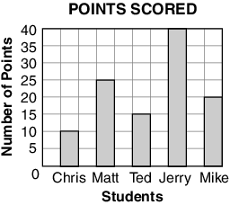  How many more points did Matt score than Mike?  What is the difference between the number of points Jerry scored than the number of points Chris scored?
27 | I can ask a question to collect data with up to four categories. (NC.3.MD.3) | Paper-Pencil Exit Ticket- Ask students to ask the question: What is your favorite fruit? Students will record their data on the following data table.  Third Graders’ Favorite Fruit  Favorite Fruit Frequency  Apple  Orange  Banana  Grapes
28 | I can make decisions about data on a frequency table to represent data on a scaled picture or scaled bar graph with up to four categories.  (NC.3.MD.3) | Paper-Pencil Exit Ticket- Students will use the data from the day before asking the question: What is your favorite fruit? and create a scaled bar graph using that data.
29 | I can create a table of data and then create a bar graph with a scale. (NC.3.MD.3) | Paper-Pencil Exit Ticket- Students will ask a question. What is your favorite flavor of ice cream? They will create a frequency table with their data and then create a scaled bar graph .
30 | I can organize data on a graph and answer questions to solve one or two step problems using information from the graph.(NC.3.MD.3) | Paper-Pencil Exit Ticket- Toni's School Supplies - MD3
31 | I can accurately read data from a graph to answer questions correctly.  (NC.3.MD.3) | Paper-Pencil Exit Ticket- Box Tops Collection - MD3
32 | I can read data on a graph to answer questions such as how many more or how many less. (NC.3.MD.3) | Formative Assessment- CFA for MD3
33 | I can solve additional problems mentally and share strategies. (NC.3.NBT.2) | Paper-Pencil Exit Ticket- Addition Number Talk - NBT2  Teacher writes the following problem on chart/board:  19+12  Students will mentally solve the problem and share the strategy they used.
34 | I can fluently add and subtract by using a strategy based on place value. (NC.3.NBT.2) | Paper-Pencil Exit Ticket-  Tim moved 336 boxes last week. He moved 380 boxes this week. How many boxes did Tim move in all?  - 600 B. 616  C. 700 D. 716  Jenni’s school has 600 students. Ellen’s school has a total of 439 students. Which is the best estimate of the difference between the number of students at the two schools?  - 100 B. 150  C. 200 D. 250
35 | I can mentally solve subtraction problems and share my thinking. (NC.3.NBT.2) | Paper-Pencil Exit Ticket- Subtraction Number Talks - NBT2  Teacher writes the following problem on chart/board:  20 - 10  Students will mentally solve the problem and share the strategy they used.
36 | I can solve addition problems on an “open” number line by adding up.  I can solve subtraction problems on an “open”number  line by adding up or subtracting back.  (NC.3.NBT.2) | Paper-Pencil Exit Ticket-  Illustrate how to solve each problem using a number line.  1. Mark has 157 comic books. His friend gave him 36 more comic books. How many comic books does Mark have now?  2. Tonya has 253 beads. She gives 131 beads to her friend. How many beads does she have now?
37 | I can use place value strategies (including expanded form) to add and subtract multi-digit numbers.  (NC.3.NBT.2) | Paper-Pencil Exit Ticket-  Your family wants to plan a vacation by traveling on Interstate 95. They aren’t sure whether they want to travel north or south. Use the following table to answer the questions below.  Destination Direction Distance from Raleigh NC  Orlando, Florida South 595 miles  New York, NY North 502 miles  Washington, DC North 278 miles  Myrtle Beach, SC South 181 miles  Richmond, VA North 170 miles  DIRECTIONS: Solve the following problems. Show your solutions.  1. Which destination is the farthest? Which destination is the closest? How do you know?  2. Which two cities are about the same distance from Raleigh? Explain your answer.
38 | I can add and subtract whole numbers up to and including 1,000. (NC.3.NBT.2) | Paper-Pencil Exit Ticket- Compatible Numbers - NBT2
39 | I can use expanded form to decompose numbers and then find sums and differences. (NC.3.NBT.2) | Paper-Pencil Exit Ticket- From 100 to 0 - NBT2
40 | I can use place value to add and subtract. (NC.3.NBT.2) | Paper-Pencil Exit Ticket- Toys for Us - NBT2
41 | I can use estimation strategies to assess reasonableness of answers. (NC.3.NBT.2) | Paper-Pencil Exit Ticket- Cafeteria Lunch Orders - NBT 2
42 | I can solve two-step word problems using strategies for addition and subtraction. (NC.3.NBT.2, NC.3.OA.8) | Paper-Pencil Exit Ticket-Multi-Step Problems Lesson  (This is a powerpoint that has information for students to solve the word problem on slides 6-9) (You can print the powerpoint or show online)
43 | I can solve two-step word problems using addition and subtraction. (NC.3.NBT.2, NC.3.OA.8) | Paper-Pencil Exit Ticket-Flexible Seating - NBT 2, OA8
44 | I can solve two-step word problems using addition and subtraction. (NC.3.NBT.2, NC.3.OA.8) | Paper-Pencil Exit Ticket-Two-Step Word Problem Practice for Cluster 3 (Teacher selects any 2-3 for an exit ticket)
45 | I can fluently add and subtract using strategies to solve two-step word problems. (NC.3.NBT.2, NC.3.OA.8) | Formative Assessment- CFA for Cluster 3

Unit/Module Pacing: 2nd Nine Weeks/Quarter 2 (45 days)

Number  of Days | Name of Unit/Module | Pre-Requisites | Standards | Academic Vocabulary | Instructional Resources
45 days | 4. Making Sense of Multiplication and Division | NC 2.OA.1  NC2.OA.2  NC2. OA.3  NC 2. OA.4  NC 2. NBT.1  NC 2. NBT.2 NC 2. NBT.5  NC 2. NBT.7 | NC 3.OA.1 NC.3.OA.2  NC.3. OA.3, NC.3.OA.6  NC.3. OA.7 NC.3.OA.8 NC.3.OA.9 NC.3.NBT.3 | multiply, divide, factor,quotient,equal groups, arrays, divisor, equations, symbols, digit, repeated addition, unknown factors, multiplication, division, dividend, product, commutative property, associative property, zero property of multiplication, place value, rounding, base ten, expanded form | Cluster 4 Resources from Tools for Teachers

Learning Targets for 2nd Nine Weeks/Quarter 2:

Making Sense of Multiplication and Division
Day # | Daily Learning Target | How will the daily learning target be assessed?  EXIT TEMPLATE Quarter 2
1 | I can illustrate and explain strategies including arrays, repeated addition, decomposing a factor and applying the commutative and associative properties. (NC.3.OA.1) | Paper-Pencil Exit Ticket- Prove It - OA1
2 | I can use an appropriate model to represent and justify the solution by writing a clear and accurate sentence explaining strategies. (NC.3.OA.1) | Paper-Pencil Exit Ticket- Road Trip - OA1
3 | I can draw a picture and write an equation to solve multiplication properties. (NC.3.OA.1) | Paper-Pencil Exit Ticket- Zeke's Dog - OA1
4 | I demonstrate multiplication by thinking about groups of objects. (NC.3.OA.1) | Paper-Pencil Exit Ticket-  1. An array has 7 equal rows of 8 squares. What was the total number of squares in the array?  - 1 B. 15  C. 56 D. 54  2. A restaurant places 5 rolls in each of 7 baskets. How many rolls were in the baskets all together?  - 2 B. 12  C. 35 D. 40
5 | I can use a picture to model an array and write an equation to solve problems. (NC.3.OA.2) | Paper-Pencil Exit Ticket- Ray's Hamster - OA2
6 | I can use a picture to write an equation to solve division problems. (NC.3.OA.2) | Paper-Pencil Exit Ticket- Sherrin's Breakfast Melon - OA2
7 | I can multiply within 100 (NC.3.OA.1) | Double Up Game Page 3  Resource: Building Conceptual Understanding and Fluency Through Games  Building Conceptual Understanding and Fluency Through Games | NC DPI
8 | I can use multiplication and division within 100 to solve word problems in situations involving equal groups, arrays, and measurement quantities, e.g., by using drawings and equations with a symbol for the unknown number to represent the problem. (NC.3.OA.3) | Paper-Pencil Exit Ticket-  The Smith family is hosting a dinner party. They set up 7 tables, and each table has 6 seats. How many guests could there be?  ● Draw a picture representation of the table setup.  ● Write an equation to represent the problem.  ● Explain your strategy in words.  Represent your solution with an equation. Explain your strategy using words, pictures, or computations.
9 | I can represent multiplication and division situations on a number line. (NC.3.OA.3) | Paper-Pencil Exit Ticket- Number Lines: Multiplication and Division - OA3  Select a problem. Draw a number line and show the Math Frog hops.  Using your problem, write an equation for multiplication.  Using your problem, write an equation for division.
10 | I can represent and solve problems involving multiplication and division. (NC.3.OA.3) | Paper-Pencil Exit Ticket- Counting Goldfish - OA3
11 | I can solve multiplication word problems with factors up to and including 10. (NC.3.OA.3) | Paper-Pencil Exit Ticket-Making Cards - OA3
12 | I can solve multiplication word problems with factors up to and including 10.  I can solve division word problems with a divisor and quotient up to and including 10. (NC.3.OA.3) | Paper-Pencil Exit Ticket- Raking Leaves - OA3
13 | I can read a word problem and determine an appropriate operation to solve the problem. (NC.3.OA.3) | Paper-Pencil Exit Ticket-  Read the following problem and determine the appropriate operation to solve the problem.  There are 30 cookies in each bag. There are 5 bags of cookies. There are 77 more cookies than gum drops. How many gumdrops are there?
14 | I can model and write an equation to solve a multiplication or division problem. (NC.3.OA.3) | Paper-Pencil Exit Ticket- Field Trip Task - OA3
15 | I can use an appropriate model to represent and justify the solution by writing a clear and accurate sentence explaining strategies. (NC.3.OA.1)  I can demonstrate my thinking about how one group of objects can be divided into smaller groups. (NC.3.OA.2)  I can solve multiplication word problems with factors up to and including 10.  I can solve division word problems with a divisor and quotient up to and including 10 (NC.3.OA.3) | Title: Formative Assessment- NC.3.OA.1/NC.3.OA.2/NC.3.OA.3  Formative Assessment -NC.3.OA.1/OA.2/OA.3
16 | I can find the missing factor in a multiplication equation.  (NC 3.OA.6) | Paper-Pencil Exit Ticket-  Write the following problems and solve for the missing factor.  ____ X 8=48 5 x ____ = 50  ____ X 2=16 7 x ____ = 63  Challenge Problems: 55 = 11 x n 35 ÷ _____ = 5
17 | I can solve an equation with an unknown factor by using division strategies and/or changing it to a multiplication problem.  (NC 3.OA.6) | Paper-Pencil Exit Ticket  Which equation can help you solve for the unknown number in 72 ÷ 9 = n?  A 9 ÷ 72 = n  B 72 × 9 = n  C n × 9 = 72  D 72 × n = 8  ***Teacher will create 2 -3 similar equations for this exit ticket.
18 | I can describe relationships between multiplication and division.  (NC 3.OA.6) | Paper-Pencil Exit Ticket- Air Tickets - OA6
19 | I can use an array or other model to prove that the multiplication fact will help you find the answer.  (NC 3.OA.6) | Paper-Pencil Exit Ticket - Planting Tomatoes - OA6
20 | I can solve an unknown-factor problem, by using division strategies.  (NC 3.OA.6) | Paper-Pencil Exit Ticket- Sharing Pencils - OA6
21 | I can solve equations by finding the missing number that involve addition, subtraction, multiplication, and/or division (NC.3.OA.6) | Find The Unknown Number Game page 24  Resource: Building Conceptual Understanding and Fluency Through Games  Building Conceptual Understanding and Fluency Through Games | NC DPI
22 | I can determine the unknown whole number in a division equation relating three whole numbers.  (NC 3.OA.7) | Paper-Pencil Exit Ticket- What is the value of in 64 ÷ = 8?  - 7 B. 8  C. 56 D. 72  ***Teacher will create 2 -3 similar equations for this exit ticket.
23 | I can determine the unknown whole number in a multiplication equation relating three whole numbers.  (NC 3.OA.7) | Paper-Pencil Exit Ticket -  Solve for the unknown number in the following multiplication equations.  n x 5 = 35  8 x n = 24  4 x n =16
24 | I can mentally solve multiplication problems and share my thinking.  (NC 3.OA.7) | Paper-Pencil Exit Ticket- Multiplication Number Talks - OA7  Write the following problem on chart/board:  2 x 6  Give students time to mentally solve the problem and share the strategy they used to find the answer.  **Teacher will create 2-3 similar equations for this exit ticket.
25 | Building Fluency: fluently multiply within 100 (NC.3.OA1, NC3.OA.7) | Snakes Alive, Go For Fives Game PAGE 7  Building Conceptual Understanding and Fluency Through Games | NC DPI
26 | I can mentally solve division problems and share my thinking.  (NC 3.OA.7) | Paper-Pencil Exit Ticket - Division Number Talks - OA7  Write the following problem on the chart/board:  72 ÷ 9  Give students time to mentally solve the problem and share the strategy they used to find the answer.  **Teacher will create 2-3 similar equations for this exit ticket.
27 | I can increase my multiplication fluency (NC.3.OA.1,NC.3.OA.7) | Game- Multiple Madness II Game
28 | I can solve two-step word problems using two of three operations for whole numbers. addition , subtraction, multiplication.  (NC 3.OA.8) | Paper-Pencil Exit Ticket -  1) The owner of a box store has 400 books to pack into boxes. On Monday he packs 236 books and on Tuesday he packs 148 books. How many more books does the owner need to pack into the boxes?  _____________ books.  Write an equation with a letter standing for the unknown quantity.  Show how you found your answer.  2) Maria was baking cupcakes for the bake sale. On Thursday, she baked 7 batches of 9 cupcakes each. On Friday, she baked 158 more cupcakes. How many cupcakes did she bake in all? ____________ cupcakes·  Write an equation with a letter standing for the unknown quantity. Show how you found your answer.
29 | I can use models and drawings to represent and solve two-step word problems. (NC 3.OA.8) | Paper-Pencil Exit Ticket- Baskets of Candy - OA8
30 | I can use a variety of solution strategies to solve problems.  (NC 3.OA.8) | Paper-Pencil Exit Ticket - Earning Money - OA8
31 | I can write equations with a letter standing for the unknown quantity.  (NC 3.OA.8) | Paper-Pencil Exit Ticket- Pack of Juice Boxes - OA8
32 | I can use pictures, words, and numbers to accurately solve two-step word problems (NC.3.OA.8) | Paper-Pencil Exit Ticket-Soccer Uniform - OA8
33 | I can use addition, subtraction, multiplication and division to solve all kinds of word problems. (NC.3.OA.8) | Paper-Pencil Exit Ticket-  1. Jeremy walked 7 miles each day for 5 days. How many miles did Jeremy walk altogether?  - 28 B. 29  C. 35 D. 56  2. A truck rental company charges $20 per day plus a one time fee of $40 to rent a truck. A person needs to rent a truck for 9 days. How much will the person pay to rent the truck?  - $540 B. $380  C. $220 D. $180
34 | I can make sense of word problems by carefully reading each problem, using numbers to solve the problem and re-read the problem again to determine if the answer makes sense. (NC 3.OA.8) | Formative Assessment- Two-Step Word Problem Practice for Cluster 4
35 | I can Interpret patterns of multiplication on a hundreds board and/or multiplication table (NC 3.OA.9) | Paper-Pencil Exit Ticket- Tanya shaded a pattern on this hundreds chart.  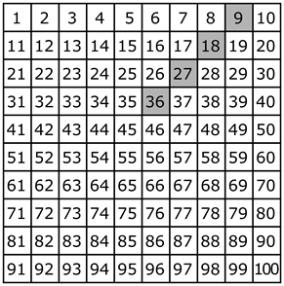  What are the next 3 numbers in the pattern?  - 45, 55, 65  - 45, 54, 63  - 46, 56, 66  - 36, 38, 40
36 | I can find a square number when I multiply another number by itself. For example, 5 times 5 equals 25 and I can build a square number and explain.  (NC 3.OA.9) | Paper-Pencil Exit Ticket - Patterns on the Multiplication Chart - OA9
37 | I can multiply one digit numbers by multiples of 10.  (NC 3.NBT.3) | Paper-Pencil Exit Ticket - Earn that Bike - NBT3
38 | I can use concrete and pictorial models to multiply by multiples of 10.  (NC 3. NBT.3) | Paper-Pencil Exit Ticket- Helping Hugh - NBT3
39 | I can use place value and the properties of operations, to find the product of a one-digit whole number by a multiple of 10 in the range 10–90.  (NC 3. NBT.3) | Paper-Pencil Exit Ticket- What's the Best Deal - NBT3
40 | I can read and write numbers, within 1000, using base-ten numerals, number names, and expanded form.  (NC 3. NBT.3) | Paper-Pencil Exit Ticket- How Many Strawberries - NBT3
41 | Building Fluency: multiply one-digit whole numbers by multiples of ten | Charlotte Speedway Race Game page 31  Building Conceptual Understanding and Fluency Through Games | NC DPI
42 | I can multiply one digit numbers by multiples of 10 using money.  (NC 3. NBT.3) | Game- Money Wheel Game
43  REVIEW DAY | Cumulative review will assess skills previously taught:  I can use equations to represent mathematical situations.  I can recognize contexts that involve multiplication and division  I can connect multiplication and division situations to multiplication expressions and equations  I can use multiplication and division within 100 to solve word problems in situations involving equal groups, arrays, and measurement quantities  I can solve problems in which you need to find the number of things in a group  I can use and represent properties of operations for multiplication  I can use the relationship between multiplication and division to solve division problems | Students will demonstrate their knowledge of previously taught standards and learning targets and results will determine reteaching and/or additional review of content in small group or one on one intervention settings, providing, additional practice in stations or center games/activities provided in lessons in this unit, and a re-assessment to determine mastery of standards/skills.
44  REVIEW DAY | I can use equations to represent mathematical situations  I can recognize contexts that involve multiplication and division  I can connect multiplication and division situations to multiplication expressions and equations  I can use multiplication and division within 100 to solve word problems in situations involving equal groups, arrays, and measurement quantities  I can solve problems in which you need to find the number of things in a group  I can use and represent properties of operations for multiplication  I can use the relationship between multiplication and division to solve division problems | Students will demonstrate their knowledge of previously taught standards and learning targets and results will determine reteaching and/or additional review of content in small group or one on one intervention settings, providing, additional practice in stations or center games/activities provided in lessons in this unit, and a re-assessment to determine mastery of standards/skills.
45  REVIEW DAY | I can use equations to represent mathematical situation  I can recognize contexts that involve multiplication and division  I can connect multiplication and division situations to multiplication expressions and equations  I can use multiplication and division within 100 to solve word problems in situations involving equal groups, arrays, and measurement quantities  I can solve problems in which you need to find the number of things in a group  I can use and represent properties of operations for multiplication  I can use the relationship between multiplication and division to solve division problems | Formative Assessment- CFA for Cluster 4  Students will demonstrate their knowledge of previously taught standards and learning targets and results will determine reteaching and/or additional review of content in small group or one on one intervention settings, providing, additional practice in stations or center games/activities provided in lessons in this unit, and a re-assessment to determine mastery of standards/skills.

Unit/Module Pacing: 3rd Nine Weeks/Quarter 3 (45 days)

Number  of Days | Name of Unit/Module | Pre-Requisites | Standards | Academic Vocabulary | Instructional Resources
5 - 10 days | 5. Reasoning with Shapes and their Attributes | NC.2.G.1 | NC.3.G.1 | Polygon, sides, quadrilateral, angles, vertex, trapezoid, parallelogram, rectangle, rhombus, square, circle, pentagon, hexagon | Cluster 5:  3rd Cluster 5 | Tools 4 NC Teachers
10- 15 days | 6. Applying the Operations to Area and Perimeter | NC.2.MD.5  NC.2.MD.7  NC.2.MD.8 | NC.3.MD.5, NC.3.MD.7, NC.3.MD.8 | Area, unit square, square unit, estimate | Cluster 6:  3rd Cluster 6 | Tools 4 NC Teachers
20 days | 7. Understanding Fractions as Parts of a Whole | NC.2.G.3 | NC.3.NF.1, NC.3.NF.2, NC.3.NF.3, NC.3.NF.4 | Numerator, denominator, equal parts, halves, thirds, fourths, sixths, eighths, partition, number line, | Cluster 7:  3rd Cluster 7 Tools 4 NC Teachers

Learning Targets for 3rd Nine Weeks/Quarter 3:

Reasoning with Shapes and their Attributes
Day # | Daily Learning Target | How will the daily learning target be assessed?  EXIT TICKET TEMPLATE Quarter 3
1 | I can Investigate, describe, and reason about composing triangles and quadrilaterals and decomposing quadrilaterals. (NC.3.G.1)  I can recognize and draw examples and non-examples of types of quadrilaterals including rhombuses, rectangles, squares, parallelograms, and trapezoids. (NC.3.G.1) | Exit Ticket: Students will draw an example of a triangle, and label the characteristics, then draw a non-example and explain why it is not considered a triangle.
2 | I can Investigate, describe, and reason about composing triangles and quadrilaterals and decomposing quadrilaterals. (NC.3.G.1)  I can recognize and draw examples and non-examples of types of quadrilaterals including rhombuses, rectangles, squares, parallelograms, and trapezoids. (NC.3.G.1) | Exit Ticket: : Students will create shapes on GeoBoard/GeoBoard paper. Students will describe the shape using vocabulary words learned during the lesson.
3 | I can Investigate, describe, and reason about composing triangles and quadrilaterals and decomposing quadrilaterals. (NC.3.G.1)  I can recognize and draw examples and non-examples of types of quadrilaterals including rhombuses, rectangles, squares, parallelograms, and trapezoids. (NC.3.G.1) | Exit Ticket: Students will sort quadrilaterals according to their attributes.
4 | I can Investigate, describe, and reason about composing triangles and quadrilaterals and decomposing quadrilaterals. (NC.3.G.1) | Exit Ticket:: Students will create and sort triangles according to their attributes.
5 | I can Investigate, describe, and reason about composing triangles and quadrilaterals and decomposing quadrilaterals. (NC.3.G.1)  I can recognize and draw examples and non-examples of types of quadrilaterals including rhombuses, rectangles, squares, parallelograms, and trapezoids. (NC.3.G.1) | Exit Ticket: Students will create and sort triangles according to their attributes.
6 | I can Investigate, describe, and reason about composing triangles and quadrilaterals and decomposing quadrilaterals. (NC.3.G.1)  I can recognize and draw examples and non-examples of types of quadrilaterals including rhombuses, rectangles, squares, parallelograms, and trapezoids. (NC.3.G.1) | Exit Ticket: Students will create and sort triangles according to their attributes.
7 | I can Investigate, describe, and reason about composing triangles and quadrilaterals and decomposing quadrilaterals. (NC.3.G.1)  I can recognize and draw examples and non-examples of types of quadrilaterals including rhombuses, rectangles, squares, parallelograms, and trapezoids. (NC.3.G.1) | Exit Ticket: Students will draw examples and non examples of quadrilaterals.
8 | I can Investigate, describe, and reason about composing triangles and quadrilaterals and decomposing quadrilaterals. (NC.3.G.1)  I can recognize and draw examples and non-examples of types of quadrilaterals including rhombuses, rectangles, squares, parallelograms, and trapezoids. (NC.3.G.1) | Students will classify shapes given.  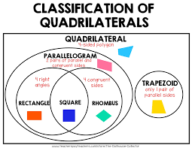
9 | I can Investigate, describe, and reason about composing triangles and quadrilaterals and decomposing quadrilaterals. (NC.3.G.1)  I can recognize and draw examples and non-examples of types of quadrilaterals including rhombuses, rectangles, squares, parallelograms, and trapezoids. (NC.3.G.1) | Exit Ticket:  1. How many sides does a quadrilateral have? 1. ______________ 2. How many pairs of parallel sides does a rectangle have? 2. ______________ 3. How many pairs of parallel sides does a trapezoid have? 3. ______________ 4. Name two quadrilaterals in which all the sides have an 4. ______________________ equal length. ______________________ 5. Name two quadrilaterals that have four right angles. 5. ______________________ ______________________
10 | I can Investigate, describe, and reason about composing triangles and quadrilaterals and decomposing quadrilaterals. (NC.3.G.1)  I can recognize and draw examples and non-examples of types of quadrilaterals including rhombuses, rectangles, squares, parallelograms, and trapezoids. (NC.3.G.1) | Exit Ticket:  Match the quadrilateral with the shape. (teacher will draw the shape)  - Parallelogram  - Rectangle  - Trapezoid  - Rhombus  - square
Applying the Operations to Area and Perimeter
11 | I can find the area of a rectangle with whole-number side lengths by tiling without gaps or overlaps and counting unit squares. (NC.3.MD.5)  I can solve problems involving perimeters of polygons, including finding the perimeter given the side lengths, and finding an unknown side length. (NC.3.MD.8 ) | Exit Ticket:  The students will use grid paper to solve this problem: Jeremy found a picture on the Internet. The dimensions of Jeremy’s picture are: Width: 4 inches Height: 6 inches Using one-inch grid paper, draw and label a rectangle to show the length and width of Jeremy’s picture.Find and label the perimeter of Jeremy’s picture. Show your solution strategy  Find and label the area of Jeremy’s picture. Show your solution strategy
12 | I can find the area of a rectangle with whole-number side lengths by tiling without gaps or overlaps and counting unit squares. (3.MD.5)  I can relate area to the operations of multiplication and addition.  I can find the area of a rectangle with whole-number side lengths by tiling it, and show that the area is the same as would be found by multiplying the side lengths.  I can use tiles and/or arrays to illustrate and explain that the area of a rectangle can be found by partitioning it into two smaller rectangles, and that the area of the large rectangle is the sum of the two smaller rectangles. (3.MD.7) | Exit ticket: Consider giving students two rectangles; one that is 6 units by 3 units and one that is 6 units by 2 units. Ask students to find the area and write an explanation about how they know which one has a larger area.
13 | I can find the area of a rectangle with whole-number side lengths by tiling without gaps or overlaps and counting unit squares. (3.MD.5)  I can relate area to the operations of multiplication and addition.  I can find the area of a rectangle with whole-number side lengths by tiling it, and show that the area is the same as would be found by multiplying the side lengths.  I can demonstrate understanding of tiles and/or arrays by illustrating and explaining that the area of a rectangle can be found by partitioning it into two smaller rectangles, and that the area of the large rectangle is the sum of the two smaller rectangles. (3.MD.7) | Exit Ticket: Students will use fraction strips to order fractions.
14 | I can find the area of a rectangle with whole-number side lengths by tiling without gaps or overlaps and counting unit squares. (3.MD.5) | Exit Ticket: Students will use graph paper to create area models.
15 | I can find the area of a rectangle with whole-number side lengths by tiling without gaps or overlaps and counting unit squares. (3.MD.5) | Exit Ticket: Students will use color tiles to create area models.  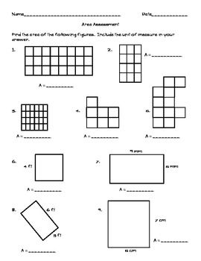  (the example shown above is from, which may require a log in: https://www.superteacherworksheets.com/index.html)
16 | I can relate area to the operations of multiplication and addition.  I can find the area of a rectangle with whole-number side lengths by tiling it, and show that the area is the same as would be found by multiplying the side lengths.  I can use tiles and/or arrays to illustrate and explain that the area of a rectangle can be found by partitioning it into two smaller rectangles, and that the area of the large rectangle is the sum of the two smaller rectangles. (3.MD.7) | Exit Ticket: Draw three different arrays that you could make with 36 square inch tiles. Label the side lengths on each  of your arrays. Write multiplication sentences for each array to prove that the area of each array is 36  square inches.
17 | I can solve real world and mathematical problems involving perimeter of polygons, involving perimeter given the side lengths, finding an unknown side length, and exhibiting rectangles with the same perimeter and different areas or with the same area and different perimeters. (3.MD.8) | 1. Katy and Jane construct a four-sided wall to surround their castle. The wall has a perimeter of 100 feet.  One side measures 16 feet. A different side measures 16 feet. A third side measures 34 feet.  a. Draw and label a diagram of the wall. Use a letter to represent the unknown side length.  b. What is the unknown side length? Show your work, or explain how you know.  c. Katy and Jane build a square fence around the castle’s pool. It has a perimeter of 36 feet. What is  the area that the fence encloses? Use a letter to represent the unknown. Show your work.
18 | I can solve real world and mathematical problems involving perimeter of polygons, involving perimeter given the side lengths, finding an unknown side length, and exhibiting rectangles with the same perimeter and different areas or with the same area and different perimeters. (3.MD.8) | The square has an area of 16 square centimeters.  a. What is the length of each side? Explain how you know.  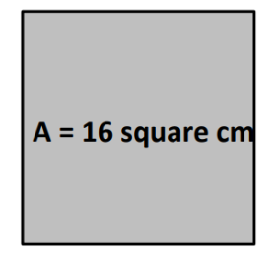  b. Draw copies of the square above to make a figure with a perimeter of 32 centimeters.  c. Write a number sentence to show that your figure has the correct perimeter of 32 centimeters.
19 | I can solve real world and mathematical problems involving perimeter of polygons, involving perimeter given the side lengths, finding an unknown side length, and exhibiting rectangles with the same perimeter and different areas or with the same area and different perimeters. (3.MD.8) | Exit Ticket: You have 24 feet of fencing. What are the possible dimensions you can have for a rectangular fenced in area?
20 | I can relate area to the operations of multiplication and addition.  I can find the area of a rectangle with whole-number side lengths by tiling it, and show that the area is the same as would be found by multiplying the side lengths.  I can use tiles and/or arrays to illustrate and explain that the area of a rectangle can be found by partitioning it into two smaller rectangles, and that the area of the large rectangle is the sum of the two smaller rectangles. (3.MD.7) | Exit ticket: Find the missing side length of the shape. Use color tiles to assist..  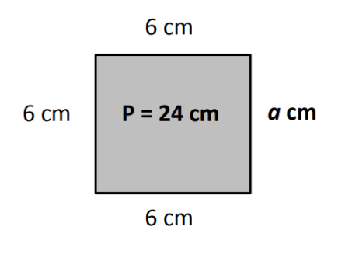
21 | I can find the area of a rectangle with whole-number side lengths by tiling without gaps or overlaps and counting unit squares. (3.MD.5) | Exit Ticket: Draw three different arrays that you could make with 36 square inch tiles. Label the side lengths on each  of your arrays. Write multiplication sentences for each array to prove that the area of each array is 36  square inches.
22 | I can relate area to the operations of multiplication and addition.  I can find the area of a rectangle with whole-number side lengths by tiling it, and show that the area is the same as would be found by multiplying the side lengths.  I can use tiles and/or arrays to illustrate and explain that the area of a rectangle can be found by partitioning it into two smaller rectangles, and that the area of the large rectangle is the sum of the two smaller rectangles. (3.MD.7) | 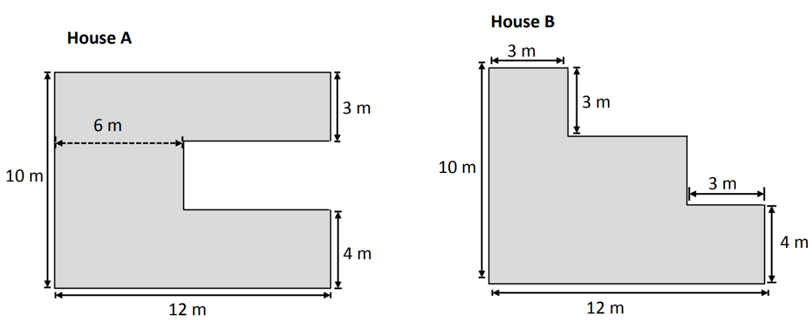  Which floor plan has the greater area? Show how you found your answer on the drawings above. Show your calculations below.
23 | I can use tiles and/or arrays to illustrate and explain that the area of a rectangle can be found by partitioning it into two smaller rectangles, and that the area of the large rectangle is the sum of the two smaller rectangles. (3.MD.7)  I can solve real world and mathematical problems involving perimeter of polygons, involving perimeter given the side lengths, finding an unknown side length, and exhibiting rectangles with the same perimeter and different areas or with the same area and different perimeters. (3.MD.8) | Superior Elementary School uses the design below for their swimming pool. Shapes A, B, and C are rectangles.  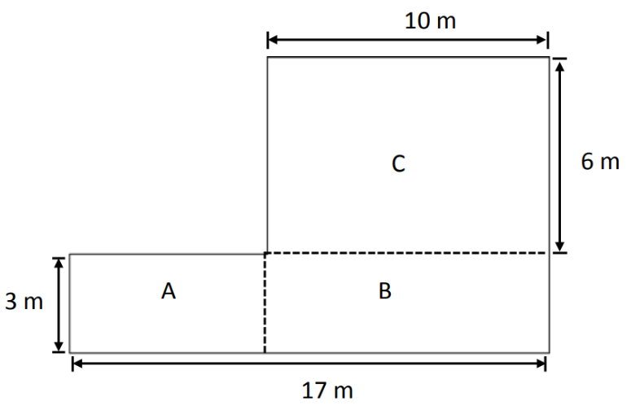  a. Label the side lengths of Rectangles A and B on the drawing.  b. Find the area of each rectangle.  c. Find the area of the entire pool. Explain how you found the area of the pool.
24 | I can solve real world and mathematical problems involving perimeter of polygons, involving perimeter given the side lengths, finding an unknown side length, and exhibiting rectangles with the same perimeter and different areas or with the same area and different perimeters. (3.MD.8) | Ashley wants to place a fence around a rectangular play area for her rabbits. The play area will be 8 feet long and 3 feet wide. What is the total length of the fence, in feet, Ashley needs to place around the play area
25 | I can solve real world and mathematical problems involving perimeter of polygons, involving perimeter given the side lengths, finding an unknown side length, and exhibiting rectangles with the same perimeter and different areas or with the same area and different perimeters. (3.MD.8) | Lavina wants to place a fence around a rectangular play area for her rabbits. The play area will be 7 feet long and 4 feet wide. What is the total length of the fence, in feet, Lavina needs to place around the play area?
Understanding Parts of a Whole
26 | I can interpret unit fractions with denominators of 2, 3, 4, 6, and 8 as quantities formed when a whole is partitioned into equal parts; • Explain that a unit fraction is one of those parts. • Represent and identify unit fractions using area and length models (NC 3.NF.1) | Exit Ticket: The student will use shapes to create fractional parts of  a whole.
27 | I can interpret unit fractions with denominators of 2, 3, 4, 6, and 8 as quantities formed when a whole is partitioned into equal parts; • Explain that a unit fraction is one of those parts. • Represent and identify unit fractions using area and length models (NC 3.NF.1) | Exit Ticket: Jerry put 7 equally spaced hooks on a straight wire so students could hang up their coats. The whole length is from the first hook to the last hook.
28 | I can interpret unit fractions with denominators of 2, 3, 4, 6, and 8 as quantities formed when a whole is partitioned into equal parts; • Explain that a unit fraction is one of those parts. • Represent and identify unit fractions using area and length models (NC 3.NF.1) | Exit Ticket: Students will use pattern blocks to create fractional parts of a whole.
29 | I can interpret unit fractions with denominators of 2, 3, 4, 6, and 8 as quantities formed when a whole is partitioned into equal parts; • Explain that a unit fraction is one of those parts. • Represent and identify unit fractions using area and length models (NC 3.NF.1) | 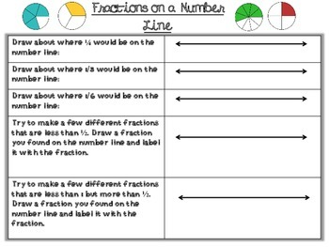
30 | I can interpret unit fractions with denominators of 2, 3, 4, 6, and 8 as quantities formed when a whole is partitioned into equal parts; • Explain that a unit fraction is one of those parts. • Represent and identify unit fractions using area and length models (NC 3.NF.1) | 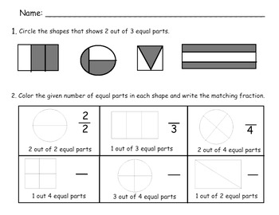
31 | I can interpret unit fractions with denominators of 2, 3, 4, 6, and 8 as quantities formed when a whole is partitioned into equal parts; • Explain that a unit fraction is one of those parts. • Represent and identify unit fractions using area and length models (NC 3.NF.1) | Exit Ticket:  https://www.k5learning.com/worksheets/math/grade-3-identify-fractions-color-a.pdf
32 | I can interpret unit fractions with denominators of 2, 3, 4, 6, and 8 as quantities formed when a whole is partitioned into equal parts; • Explain that a unit fraction is one of those parts. • Represent and identify unit fractions using area and length models (NC 3.NF.1) | Exit Ticket:  https://www.k5learning.com/worksheets/math/grade-3-identify-fractions-color-b.pdf
33 | I can represent a fraction as a number on the number line, using a line diagram.  I can create an area model, explain that the numerator of a fraction represents the number of equal parts of the unit fraction. • Using a number line, explain that the numerator of a fraction represents the number of lengths of the unit fraction from 0.  (NC 3.NF.2) | Exit Ticket:  Mrs. Turner says to the class, “Last weekend I saw a garden. The garden had equal sized sections and the following flowers: 3 8 of the garden had red roses, 1 8 of the garden had purple tulips, and 4 8 of the garden had yellow sunflowers. Draw a picture of the garden and label the different parts. Write an explanation on how you determined how to label the sunflowers.
34 | I can a fraction as a number on the number line, represent fractions on a number line diagram, using an area model, and explain that the numerator of a fraction represents the number of equal parts of the unit fraction. • Using a number line, explain that the numerator of a fraction represents the number of lengths of the unit fraction from 0.  . (NC 3.NF.2) | Exit Ticket:  Mike runs on a straight road for 1 mile. Mike stops 2 3 of the way down the road to stretch. Draw a number line that shows where Mike stopped to stretch. Write an explanation about how you knew where to mark where Mike stopped to stretch on the number line.
35 | I can understand a fraction as a number on the number line, represent fractions on a number line diagram.  • Using an area model, explain that the numerator of a fraction represents the number of equal parts of the unit fraction. • Using a number line, explain that the numerator of a fraction represents the number of lengths of the unit fraction from 0.  (NC 3.NF.2) | Exit Ticket:  3.NF.2 integrated with 3.MD.2 where fractions may go beyond 1 Brandi is making hair bows. Each hair bow takes 1 4 of a yard of ribbon to make. This is what she bought at the store: If she uses all the ribbon, how many 1-4 long is the ribbon? Express the length of the ribbon as fraction.
36 | I can understand a fraction as a number on the number line, represent fractions on a number line diagram.  • Using an area model, explain that the numerator of a fraction represents the number of equal parts of the unit fraction. • Using a number line, explain that the numerator of a fraction represents the number of lengths of the unit fraction from 0.  (NC 3.NF.2) | 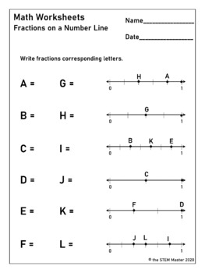  https://www.superteacherworksheets.com/index.html  Please use this as an example of how the exit ticket can look.
37 | I can understand a fraction as a number on the number line, represent fractions on a number line diagram.  I can use an area model to demonstrate and explain that the numerator of a fraction represents the number of equal parts of the unit fraction. • Using a number line, explain that the numerator of a fraction represents the number of lengths of the unit fraction from 0.  (NC 3.NF.2) | 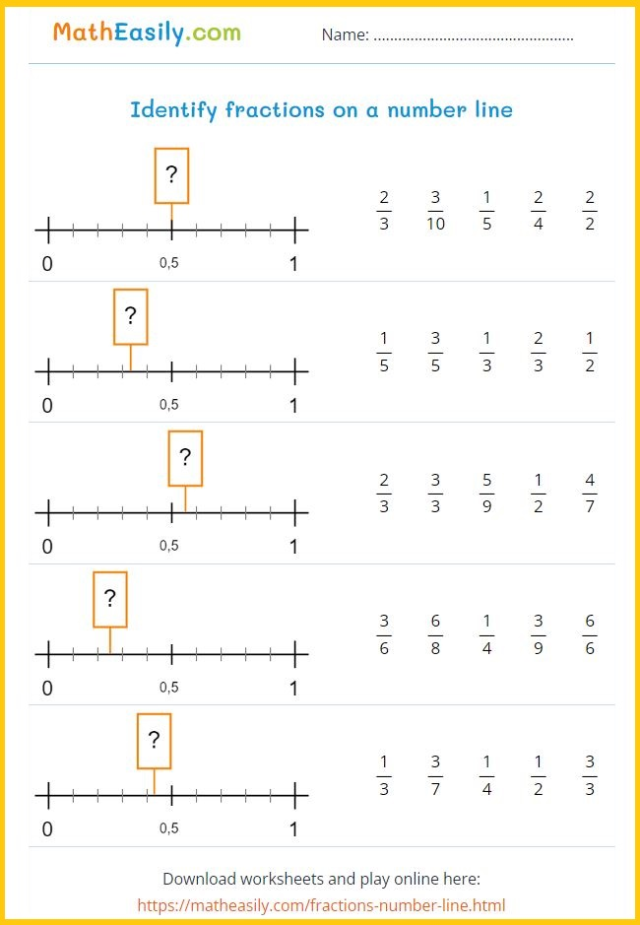  https://matheasily.com/fractions-number-line.html  Please use as an example of how the exit ticket can look.
38 | I can represent equivalent fractions with area and length models by: • Composing and decomposing fractions into equivalent fractions using related fractions: halves, fourths and eighths; thirds and sixths. • Explaining that a fraction with the same numerator and denominator equals one whole. • Expressing whole numbers as fractions, and recognize fractions that are equivalent to whole numbers. (3.NF.3) | Fractional Parts of Rectangles Activity  https://tools4ncteachers.com/resources/3-third-grade/lessons/cluster-7/nf3-fractional-parts-of-rectangles.docx
39 | I can represent equivalent fractions with area and length models by: • Composing and decomposing fractions into equivalent fractions using related fractions: halves, fourths and eighths; thirds and sixths. • Explaining that a fraction with the same numerator and denominator equals one whole. • Expressing whole numbers as fractions, and recognize fractions that are equivalent to whole numbers. (3.NF.3) | Exit Ticket:  Which is greater 3/4 or 1/4?  5/6 or 2/8?  5/7 or 5/5?
40 | I can interpret unit fractions with denominators of 2, 3, 4, 6, and 8 as quantities formed when a whole is partitioned into equal parts; • Explain that a unit fraction is one of those parts. • Represent and identify unit fractions using area and length models (NC 3.NF.1) | If I Were a Fraction Activity  https://tools4ncteachers.com/resources/district-leaders/documents/c7-3nf1lesson-if-i-were-a-fraction.docx
41 | I can represent equivalent fractions with area and length models by: • Composing and decomposing fractions into equivalent fractions using related fractions: halves, fourths and eighths; thirds and sixths. • Explaining that a fraction with the same numerator and denominator equals one whole. • Expressing whole numbers as fractions, and recognize fractions that are equivalent to whole numbers. (3.NF.3) | Creating Fraction Strips Activity  https://tools4ncteachers.com/resources/district-leaders/documents/c7-3nf3-lesson-creatingfractionstrips.docx
42 | I can represent equivalent fractions with area and length models by: • Composing and decomposing fractions into equivalent fractions using related fractions: halves, fourths and eighths; thirds and sixths. • Explaining that a fraction with the same numerator and denominator equals one whole. • Expressing whole numbers as fractions, and recognize fractions that are equivalent to whole numbers. (3.NF.3) | Exit Ticket:  Which is greater 2/4 or ½? ¾ or 2/4? ⅓ or ½?
43 | I can represent equivalent fractions with area and length models by: • Composing and decomposing fractions into equivalent fractions using related fractions: halves, fourths and eighths; thirds and sixths. • Explaining that a fraction with the same numerator and denominator equals one whole. • Expressing whole numbers as fractions, and recognize fractions that are equivalent to whole numbers. (3.NF.3) | Please use the worksheet as an example:  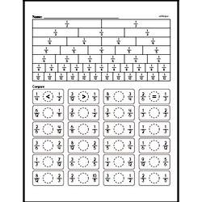  https://www.superteacherworksheets.com/index.html
44 | I can represent equivalent fractions with area and length models by: • Composing and decomposing fractions into equivalent fractions using related fractions: halves, fourths and eighths; thirds and sixths. • Explaining that a fraction with the same numerator and denominator equals one whole. • Expressing whole numbers as fractions, and recognize fractions that are equivalent to whole numbers. (3.NF.3) | 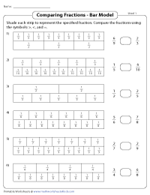  https://www.superteacherworksheets.com/index.html  Please use the worksheet as an example of how the exit ticket can look.
45 | I can represent equivalent fractions with area and length models by: • Composing and decomposing fractions into equivalent fractions using related fractions: halves, fourths and eighths; thirds and sixths. • Explaining that a fraction with the same numerator and denominator equals one whole. • Expressing whole numbers as fractions, and recognize fractions that are equivalent to whole numbers. (3.NF.3) | 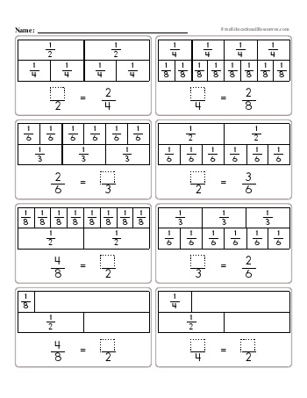  https://www.superteacherworksheets.com/index.html  Please use the worksheet as an example.

Unit/Module Pacing: 4th Nine Weeks/Quarter 4 (45 days)

Number  of Days | Name of Unit/Module | Pre-Requisites | Standards | Academic Vocabulary | Instructional Resources
10 days | 7.Understanding Fractions as Parts of a Whole | NC.2.G.3 | NC.3.NF.1, NC.3.NF.2, NC.3.NF.3, NC.3.NF.4 | Numerator, denominator, equal parts, halves, thirds, fourths, sixths, eighths, partition, number line, | 3rd Cluster 7 | Tools 4 NC Teachers
5-10 | 8. Using Tools to Measure Length, Weight, and Capacity | NC.2.MD.1  NC.2.MD.2 | NC.3. MD.2 | foot, inch, measure, ruler, yard, yardstick, predict, capacity, cup, pint, quart, gallon, weight, measurement, ounces, pounds, estimate, length | 3rd Cluster 8 | Tools 4 NC Teachers
10 | 9. Understanding Time | NC.2.MD.7 | NC.3. MD.1 | end time, elapsed time, hour, minute, start time, | 3rd Cluster 9 | Tools 4 NC Teachers
10 days - EOG Review & Testing Window (typically reserved for the last 10 days of school)

Learning Targets for 4th Nine Weeks/Quarter 4:

Understanding Fractions as Parts of a Whole
Day # | Daily Learning Target | How will the daily learning target be assessed?  EXIT TICKET TEMPLATE Q4
1 | I can represent equivalent fractions with area and length models by: • Composing and decomposing fractions into equivalent fractions using related fractions: halves, fourths and eighths; thirds and sixths. • Explaining that a fraction with the same numerator and denominator equals one whole. • Expressing whole numbers as fractions, and recognize fractions that are equivalent to whole numbers. (3.NF.3) | https://www.k5learning.com/worksheets/math/grade-3-equivalent-fractions-chart-a.pdf
2 | I can represent equivalent fractions with area and length models by: • Composing and decomposing fractions into equivalent fractions using related fractions: halves, fourths and eighths; thirds and sixths. • Explaining that a fraction with the same numerator and denominator equals one whole. • Expressing whole numbers as fractions, and recognize fractions that are equivalent to whole numbers. (3.NF.3) | https://www.k5learning.com/worksheets/math/grade-3-equivalent-fractions-chart-a.pdf
3 | I can represent equivalent fractions with area and length models by: • Composing and decomposing fractions into equivalent fractions using related fractions: halves, fourths and eighths; thirds and sixths. • Explaining that a fraction with the same numerator and denominator equals one whole. • Expressing whole numbers as fractions, and recognize fractions that are equivalent to whole numbers. (3.NF.3) | https://www.k5learning.com/worksheets/math/grade-3-equivalent-fractions-chart-b.pdf
4 | I can represent equivalent fractions with area and length models by: • Composing and decomposing fractions into equivalent fractions using related fractions: halves, fourths and eighths; thirds and sixths. • Explaining that a fraction with the same numerator and denominator equals one whole. • Expressing whole numbers as fractions, and recognize fractions that are equivalent to whole numbers. (3.NF.3) | https://www.k5learning.com/worksheets/math/grade-3-equivalent-fractions-chart-d.pdf
5 | I can represent equivalent fractions with area and length models by: • Composing and decomposing fractions into equivalent fractions using related fractions: halves, fourths and eighths; thirds and sixths. • Explaining that a fraction with the same numerator and denominator equals one whole. • Expressing whole numbers as fractions, and recognize fractions that are equivalent to whole numbers. (3.NF.3) | https://www.k5learning.com/worksheets/math/grade-3-comparing-proper-and-improper-fractions-a.pdf
6 | I can compare two fractions with the same numerator or the same denominator by reasoning about their size, using area and length models, and using the >, <, and = symbols. Recognize that comparisons are valid only when the two fractions refer to the same whole with denominators: halves, fourths and eighths; thirds and sixths. NC.3.NF.4 | Exit Ticket: Harriet and Monique are each eating a piece of licorice. Harriet eats 4/6 of her piece while Monique eats 5/6 of her piece. Who ate less? Draw a picture and write an explanation about how you determined who ate a smaller amount?
7 | I can compare two fractions with the same numerator or the same denominator by reasoning about their size, using area and length models, and using the >, <, and = symbols. Recognize that comparisons are valid only when the two fractions refer to the same whole with denominators: halves, fourths and eighths; thirds and sixths. NC.3.NF.4 | Exit Ticket: Luke and Tyrone each buy a medium pizza. Luke has his pizza cut into 8 pieces while Tyrone has his pizza cut into 6 pieces. If they each eat 3 pieces, who ate more? Draw a picture and write an explanation about how you know you are correct.
8 | I can compare two fractions with the same numerator or the same denominator by reasoning about their size, using area and length models, and using the >, <, and = symbols. Recognize that comparisons are valid only when the two fractions refer to the same whole with denominators: halves, fourths and eighths; thirds and sixths. NC.3.NF.4 | Exit Ticket: The student will draw representations of two fractions and compare the two illustrations.
9 | I can compare two fractions with the same numerator or the same denominator by reasoning about their size, using area and length models, and using the >, <, and = symbols. Recognize that comparisons are valid only when the two fractions refer to the same whole with denominators: halves, fourths and eighths; thirds and sixths. NC.3.NF.4 | Exit Ticket:  The student will draw representations of two fractions and compare the two illustrations using comparison symbols.
10 | I can compare two fractions with the same numerator or the same denominator by reasoning about their size, using area and length models, and using the >, <, and = symbols. Recognize that comparisons are valid only when the two fractions refer to the same whole with denominators: halves, fourths and eighths; thirds and sixths. NC.3.NF.4 | Exit Ticket:  The student will draw representations of two fractions and compare the two illustrations using comparison symbols.
11 | I can measure liquid volumes and masses of objects using standard units (grams, kilograms, and liters). | Exit ticket- ​​Drinking Water - MD2
12 | I can measure liquid volumes and masses of objects using standard units (grams, kilograms, and liters) | Exit ticket- Measuring Pencil Length - MD2
13 | I can measure liquid volumes and masses of objects using standard units (grams, kilograms, and liters) | Exit ticket-Measuring School Supplies - MD2
14 | I can measure liquid volumes and masses of objects using standard units (grams, kilograms, and liters) | Exit ticket-Water Pipe Length - MD2
15 | I can solve problems involving customary measurement. | Exit ticket-Austin's Trail Mix - MD2
16 | I can solve problems involving customary measurement. | Exit ticket-Farmer Lee's Cider - MD2
17 | I can solve problems involving customary measurement. | Exit ticket-Lunch Table Lengths - MD2
18 | I can solve problems involving customary measurement. | Exit ticket-Weight Sort Task - MD2
19 | I can solve problems involving customary measurement. | Exit ticket-Weighing a Beach Ball - MD2
20 | I can solve problems involving customary measurement. | Exit ticket-Party Punch - MD2
21 | I can solve problems involving liquid volumes and masses of objects. | Exit ticket-. My punch recipe needs 5 cups of orange juice and 3 cups of ice cream to make punch. If I double my punch recipe, how many liters of punch will I make?  A 8 cups B 16 cups  C 30 cups D 32 cups
22 | I can solve problems involving liquid volumes and masses of objects. | Exit ticket- If Komora is measuring the weight of her pen, which unit should she use?  A cups B pounds  C pints D ounces
23 | I can solve problems involving liquid volumes and masses of objects. | Exit ticket- You are planning to fill a large fish tank with water. Which unit might you use to measure the amount of water needed for the fish tank?  A quarts B gallons  C pounds D inches
24 | I can solve problems involving liquid volumes and masses of objects. | Exit ticket- Carla and Mikela went to the county fair and saw pumpkins on scales. Carla’s pumpkin weighed 9 pounds. Carla’s pumpkin weighed 7 pounds less than Mikela’s pumpkin.  What was the combined weight of the pumpkins?  A 25 pounds B 11 pounds  C 16 pounds D 2 pounds
25 | I can solve problems involving liquid volumes and masses of objects. | Exit ticket- . Jose and Rashik are making a tree house swing. Jose has a rope that is 75 inches long. Rashik has a rope that is 127 inches long. If they connected their ropes, how long would the new rope be?  A 52 inches B 102 inches  C 192 inches D 202 inches
26 | I can tell and write time to the nearest minute | Exit ticket- Mia's Saturday Schedule - MD1  Fun math game create https://kahoot.com/schools-u/
27 | I can tell and write time to the nearest minute | Exit ticket-Amelia's Picnic - MD1  Fun math game create https://kahoot.com/schools-u/
28 | I can tell and write time to the nearest minute | Exit ticket-Edna's Busy Day - MD1  Fun math game create https://kahoot.com/schools-u/
29 | I can tell and write time to the nearest minute | Exit ticket-Getting Ready for School - MD1  Fun math game create https://kahoot.com/schools-u/
30 | I can tell and write time to the nearest minute | Exit ticket-Morning Schedule - MD1  Fun math game create https://kahoot.com/schools-u/
31 | I can measure intervals of time in hours and minutes | Exit ticket-Norman's Number Line - MD1  Sammy got home from school at 3:10. He has baseball practice at 3:45. How much time does he have to do his homework before his practice starts?
32 | I can measure intervals of time in hours and minutes | Exit ticket-Billy's Math Task - MD1  Students are completing silent reading time. They begin at 1:14 and stop at 1:40. How many minutes do the students read?
33 | Solve word problems involving addition and subtraction of time intervals within the same hour | Exit ticket-School Schedule - MD1  David has a football game at 9:45 on Saturday morning. If it takes him 12 minutes to get to the field, what time should David leave to make the game on time?
34 | Solve word problems involving addition and subtraction of time intervals within the same hour | Exit ticket-Getting to the Bus on Time - MD1  Sierra and Zach are walking home from school. It takes them 23 minutes to walk home. They got home at 2:48. What time did they leave school?
35 | Solve word problems involving addition and subtraction of time intervals within the same hour | Exit ticket-Town Race - MD1  Gabe is excited about recess. His teacher said they have 16 minutes until they go outside. If it is 12:03, what time will his class go to recess?
36-45 | EOG Review & Testing Window (typically reserved for the last 10 days of the school year)  Learning targets for review days may vary depending upon student needs. It is best practice to personalize learning targets for student groups based on performance data from formative assessments.

