Resources Provided by NC Department of Public Instruction (NCDPI):

Unpacking Document  Vertical Progression for ELA | EOG Test Specifications | NC Check-In 2.0 Information | Released EOG | DIBELS 8th Edition Administration and Scoring Guide
Standard Course of Study | Reading Foundational Skills Continuum | Standards-Based Resources | 3rd Grade Learning Progressions | Literacy Instructional Standards 3-5

Other Resources:

ReadWorks | Kentucky Texts Sets | Padlet | Commonlit | Quizlet
Kahoot | UFLI Literacy | Engage NY | Vocabulary.com | Reading Vine
Florida Center for Reading Research (FCRR) | Bloom’s Taxonomy (Measurable Verbs) https://www.utica.edu/academic/ | Question Stems | NC Educator Resources | Login | Gimkit
12-Powerful Academic Words PDF | Spelling City Teacher Resources | 3rd Grade ELA Standard Bookmark | Learning Farm | eSpark Learning

Templates - Graphic Organizers and Penmanship:

Frayer Model | Plot Diagram | Story Map | Summary
Spelling City Teacher Resources | Worksheet Works (Cursive Practice and Print) |  | Graphic Organizers

School Year at a Glance:

Domain/Cluster/Strand | Standards
 | 1st Nine Weeks | 2nd Nine Weeks | 3rd Nine Weeks | 4th Nine Weeks
Reading Literature | RL 3.1 RL.3.2 RL 3.3  RL.3.4 RL.3.7 | RL 3.1 RL 3.5 RL 3.6 | RL3.2 RL3.3 RL.3.4 RL.3.5 RL.3.10 | RL.3.1 RL.3.4  RL.3.9 RL.3.10
Reading Informational Text | RI.3.1 RI.3.2 RI3.4 RI3.5 | RI 3.1 RI.3.3 RI.3.5 RI.3.6 RI3.7 RI3.8 | RI 3.1 RI3.4 RI.3.8 RI.3.9 RI.3.10 | RI.3.2 RI.3.3 RI3.4  RI.3.10
Reading Foundational Skills | RF.3.2 (Handwriting)  RF.3.4d  RF.3.5. | RF3.4a  RF3.4b  RF.3.5 | RF3.4  RF.3.5 | RF3.4  RF.3.5
Language | L.3.1 L.3.2 L.3.3  L.3.4 & L.3.5(Assessable standards for RTA) | L.3.1 L.3.2 L.3.3  L.3.4 & L.3.5(Assessable standards for RTA)  L.3.6 | L.3.1 L.3.2 L.3.3  L.3.4 & L.3.5(Assessable standards for RTA) | L.3.1 L.3.2 L.3.3  L.3.4 & L.3.5(Assessable standards for RTA)  L.3.6
Writing | W.3.3  W.3.4  W.3.6 | W.3.1  W.3.5  W.3.6 | W.3.2  W.3.5  W.3.6 | W.3.4  W.3.5  W.3.6
Speaking and Listening | SL.3.1  SL.3.2  SL.3.4 | SL.3.1  SL.3.5 | SL.3.3  SL.3.4  SL.3.5 | SL.3.1  SL.3.2  SL.3.5

Unit/Module Pacing:

Number  of Days | Name of Unit/Module | Pre-Requisites | Standards | Academic Vocabulary | Instructional Resources
1st Nine Weeks
15 days | Why are questions important? | RL.2.1 Ask and answer such questions as who, what, where, when, why, and how to demonstrate understanding of key details in a text.  RI.2.1 Ask and answer such questions as who, what, where, when, why, and how to demonstrate understanding of key details in a text.  RF.2 Know and apply grade-level phonics and word analysis skills in decoding words.  a. Distinguish long and short vowels when reading regularly spelled one-syllable words. b. Know spelling-sound correspondences for additional common vowel teams.  c. Decode regularly spelled two syllable words with long vowels.  d. Decode words with common prefixes and suffixes.  e. Identify words with inconsistent but common spelling-sound correspondences.  f. Recognize and read grade appropriate irregularly spelled words.  L.2.1 Demonstrate command of the conventions of standard English grammar and usage when writing or speaking; demonstrate proficiency within the 2-3 grammar continuum.  W.2.3 Write narratives in which they recount a well-elaborated event or short sequence of events, include details to describe actions, thoughts, and feelings, use temporal transition words to signal event order, and provide a sense of closure.  a. With guidance and support from adults, organize information and ideas around a topic to plan and prepare to write.  b. With guidance and support from adults and peers, focus on a topic and strengthen writing as needed by revising and editing | RL.3.1: Ask and answer questions to demonstrate understanding of a text, referring explicitly to the text as the basis for the answers.  RI.3.1: Ask and answer questions to demonstrate understanding of a text, referring explicitly to the text as the basis for the answers.  RI.3.5: Use text features and search tools to locate information relevant to a given topic efficiently.  RF.3.2 Create readable documents with legible handwriting (manuscript and cursive).  Week 3: Down Curve letters a, c, d, o, g  RF.3.4 Know and apply grade-level phonics and word analysis skills in decoding words.  RF.3.4d. Read grade-appropriate irregularly spelled words.  Six Syllable Type Review  Week 1: Open and Closed single/multisyllabic  Week 2: Silent e/Vowel team  Week 3: Vowel teams  L.3.1 Demonstrate command of the conventions of standard English grammar and usage when writing or speaking; demonstrate proficiency within the 2-3 grammar continuum.  Week 1: Simple sentences  Week 2: Subject and predicate  Week 3: Compound sentences/conjunctions/ quotation marks  SL.3.1 Engage effectively in a range of collaborative discussions (one-on-one, in groups, and teacher-led) with diverse partners on grade 3 topics and texts, building on others’ ideas and expressing their own clearly.  a. Come to discussions prepared, having read or studied required material; explicitly draw on that preparation and other information known about the topic to explore ideas under discussion.  b. Follow agreed-upon rules for discussions.  c. Ask questions to check understanding of information presented, stay on topic, and link their comments to the remarks of others. d. Explain their own ideas and understanding in light of the discussion.  W.3.3: Write narratives to develop real or imagined experiences or events using effective technique, descriptive details, and clear event sequences.  - Establish a situation and introduce a narrator and/or characters; organize an event sequence that unfolds naturally.  - Use dialogue and descriptions of actions, thoughts, and feelings to develop experiences and events or show the response of characters to situations.  - Use temporal words and phrases to signal event order.  - Provide a sense of closure. | RL.3.1 and RI.3.1  Ask  Answer  Questions  Informational  Text  Evidence  explicit, explicitly  RI.3.5  Text features  Side bars  Headings  Captions  Diagrams  Indexes  RF.3.2  Strokes  Legible  Manuscript  Cursive  RF.3.4  Syllables  Multisyllabic  Decode  W.3.3  Narratives  Sequence of events  Temporal transition words  Revising  Editing | (RL.3.1 and RI.3.1)  ReThink Education Model Lesson RL.3.1  Question Answer Relationship (QAR)  QAR Lesson Plan  Florida Center for Reading Research (FCRR)  Portfolio Passages  -----------------------  University of Florida Institute  RF.3.4  Six Syllable Types Mini lessons  The 4 Must-Know Syllable Division  Rules for Teaching Reading  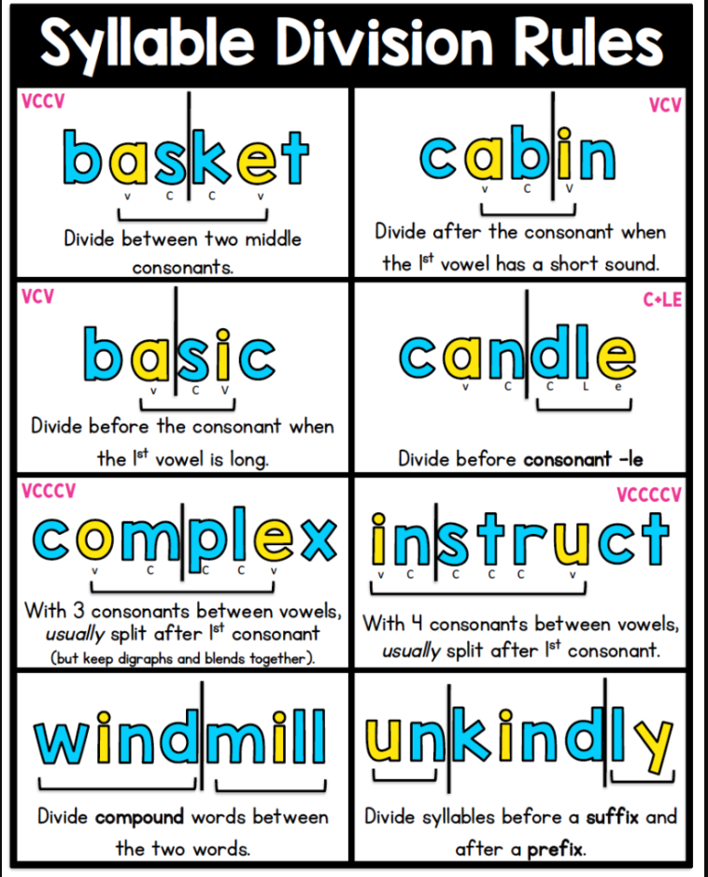  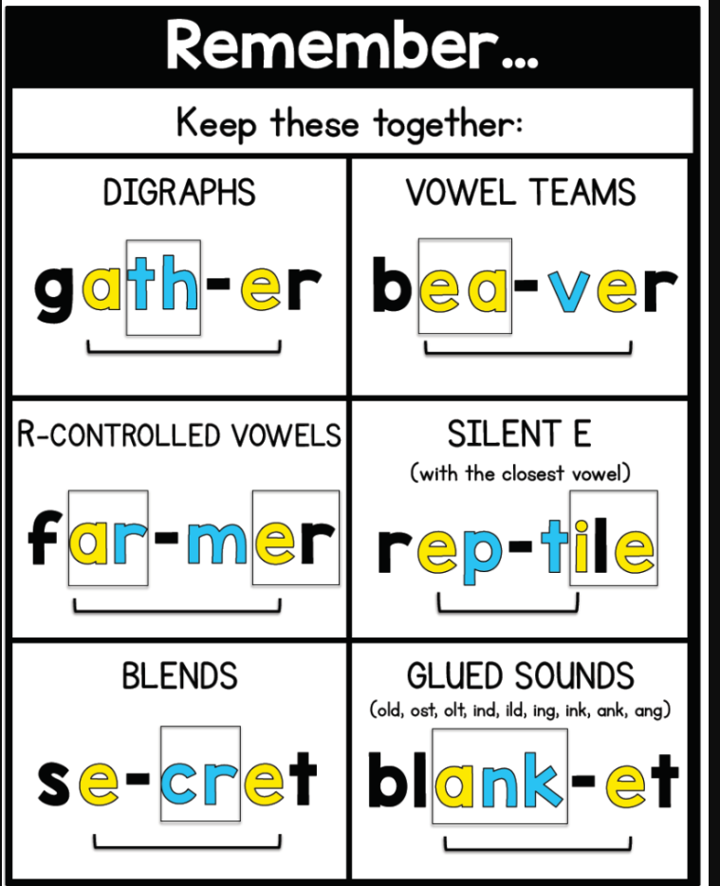  RF.3.2 Resources  Cursive Writing  Cursive Writing  Worksheet Works (cursive practice)
15 days | What is the big idea? | RL.2.2 Recount stories, including fables and folktales from diverse cultures, and determine their central message, lesson, or moral.  RI.2.2 Identify the main topic of a multi-paragraph text as well as the focus of specific paragraphs within the text.  W.2.3 Write narratives in which they recount a well-elaborated event or short sequence of events, include details to describe actions, thoughts, and feelings, use temporal transition words to signal event order, and provide a sense of closure.  a. With guidance and support from adults, organize information and ideas around a topic to plan and prepare to write.  b. With guidance and support from adults and peers, focus on a topic and strengthen writing as needed by revising and editing | RL.3.2 Recount stories, including fables, folktales, and myths from diverse cultures; determine the central message, lesson, or moral and explain how it is conveyed through key details in the text.  RI.3.2 Determine the main idea of a text; recount the key details and explain how they support the main idea.  RF.3.4d. Read grade-appropriate irregularly spelled words.  Week 4: Vowel team diphthongs  Week 5: R-controlled  Week 6: Consonant le/CLOVER  SL.3.2 Determine the main ideas and supporting details of a text read aloud or information presented in diverse media and formats, including visually, quantitatively, and orally.  L.3.1 Demonstrate command of the conventions of standard English grammar and usage when writing or speaking; demonstrate proficiency within the 2-3 grammar continuum.  Week 4: Adjectives/commas/ Comparative Adjectives  Week 5: Common and proper nouns  Week 6: Singular/Plural nouns  RF.3.2 Create readable documents with legible handwriting (manuscript and cursive).  Week 4: Down curve q - dog, go, dad, odd  Week 5: Down Curve letters A, O, C, D, E  Week 6: Undercurve letters i, j, e, l, b  W.3.3: Write narratives to develop real or imagined experiences or events using effective technique, descriptive details, and clear event sequences.  - Establish a situation and introduce a narrator and/or characters; organize an event sequence that unfolds naturally.  - Use dialogue and descriptions of actions, thoughts, and feelings to develop experiences and events or show the response of characters to situations.  - Use temporal words and phrases to signal event order.  - Provide a sense of closure. | RI.3.2  Determine  Main idea  Informational  Text  Identify  Key details  Supporting Details  RL.3.2  Support  Recount  Moral  Central Message  Explain  W.3.3  Narratives  Sequence of events  Temporal transition words  Revising  Editing | RTA Grade Portfolio Released - NC DPI  Below is a unit from Readworks focused on RL3.2 (3 lessons)  Readworks Lesson 1 RL.3.2 Theme  Readworks Lesson 2 RL.3.2 Theme  Readworks Lesson 3 RL.3.2 Theme  RI.3.2 Resources  MI Graphic Organizer  Main Idea Lesson RI.3.2  Readworks Lesson on Main Idea  Digital Main Idea Activity RI.3.2
10 days | Characters: What or Who Keeps the Story Going? | RL.2.3 Describe how characters in a story respond to major events and challenges.  RL.2.4 Describe how words and phrases supply rhythm and meaning in a story, poem, or song.  W.2.3 Write narratives in which they recount a well-elaborated event or short sequence of events, include details to describe actions, thoughts, and feelings, use temporal transition words to signal event order, and provide a sense of closure.  a. With guidance and support from adults, organize information and ideas around a topic to plan and prepare to write.  b. With guidance and support from adults and peers, focus on a topic and strengthen writing as needed by revising and editing | RL.3.3: Describe characters in a story and explain how their actions contribute to the sequence of events.  RL.3.4: Determine the meaning of words and phrases as they are used in a text, identifying words that impact the meaning in a text.  RL.3.7 Explain how specific aspects of a text’s illustrations contribute to what is conveyed by the words in a story.  RF.3.2 Create readable documents with legible handwriting (manuscript and cursive).  Week 7: Undercurve letters s, P, B, R, L  Week 8: Undercurve letter G and review needed letters  RF3.4 Know and apply grade-level phonics and word analysis skills in decoding words.  D. Read grade-appropriate irregularly spelled words.  Week 7: Schwa/Digraphs  Week 8: VC/CV  L.3.1 Demonstrate command of the conventions of standard English grammar and usage when writing or speaking; demonstrate proficiency within the 2-3 grammar continuum.  Week 7: Irregular Plural nouns  Week 8: Singular Possessive nouns/apostrophe  Week 9: Review | RL.3.3  Describe  Characters  Affect  Story  Sequence  Order of Events  Details  Contribute  Text  RL.3.4  Determine  Phrases  Literal  Non-Literal  Inferential  Distinguish  Figurative Language  Idioms  Simile  Metaphor  RI3.7  Illustrations  W.3.3  Narratives  Sequence of events  Temporal transition words  Revising  Editing | Character Maps (RL.3.3)  RTA Grade Portfolio Released - NC DPI  Explicit Plan for New Vocabulary Words RL.3.4  RL.3.3 Lesson Plan  Video RL.3.3  Here are books for teaching students to identify character traits:  Ada Twist, Scientist by Andrea Beaty  The Paper Bag Princess by Robert Munsch  The Recess Queen by Alexis O'Neill  Thank You, Mr. Falker by Patricia Polacco  The Invisible Boy by Trudy Ludwig  The Very Impatient Caterpillar by Ross Burach  A Bad Case of Stripes by David Shannon  The Good Egg by Jory John  Sheila Rae the Brave by Kevin Henkes  Boundless Grace by Mary Hoffman
5 days | Review/Check-In #1 Suggested Timeline: At the end of unit 1.
NC Check-In #1 Suggested Timeline: End of Quarter 1
2nd Nine Weeks
Number  of Days | Name of Unit/Module | Pre-Requisites | Standards | Academic Vocabulary | Instructional Resources
15 days | Let’s Get Connected | RI.2.3 Describe the connection between a series of historical events, scientific ideas or concepts, or steps in technical procedures in a text.  RL.2.5 Describe the overall structure of a story, including describing how the beginning introduces the story, the events unfold in the middle, and the ending concludes the action.  L.2.5 Demonstrate understanding of nuances in word meanings.  a. Distinguish shades of meaning among closely related verbs and closely related adjectives  L.2.1 Demonstrate command of the conventions of standard English grammar and usage when writing or speaking; demonstrate proficiency within the 2-3 grammar continuum.  RF.2.2 Print all upper- and lowercase letters legibly and proportionallyPrint all upper- and lowercase letters legibly and proportionally. | RI.3.3: Describe the relationship between a series of historical events, scientific ideas or concepts, or steps in technical procedures in a text, using language that pertains to time, sequence, and cause/effect.  RL.3.5 Refer to parts of stories, dramas, and poems when writing or speaking about a text, using terms such as chapter, scene, and stanza; describe how each successive part builds on earlier sections.  L.3.5 Demonstrate understanding of nuances in word meanings.  a. Distinguish the literal and  nonliteral meanings of words  and phrases in context.  b. Distinguish shades of meaning  among related words that  describe states of mind or  degrees of certainty  SL.3.5 Create engaging audio recordings of stories or poems that demonstrate fluid reading at an understandable pace; add visual displays when appropriate to emphasize or enhance certain facts or details.  L.3.1 Demonstrate command of the conventions of standard English grammar and usage when writing or speaking; demonstrate proficiency within the 2-3 grammar continuum.  Week 10: Plural Possessive nouns/apostrophe  Week 11: Verbs/Helper verbs  Week 12: Subject/Verb agreement  RF.3.2 Create readable documents with legible handwriting (manuscript and cursive).  Week 10: ill, bill, sell, is, Bill  Week 11: Overcurve letters m, n, v, y, x  Week 12: Overcurve letters I, J, Q  W.3.1 Write opinion pieces on topics or texts, supporting a point of view with reasons.  a. Organize information and ideas around a topic to plan and prepare to write.  b. Introduce the topic or text they are writing about, state an opinion, and create an organizational structure that lists reasons.  c. Provide reasons that support the opinion.  d. Use linking words and phrases to connect opinion and reasons.  e. Provide a concluding statement or section.  f. With guidance and support from peers and adults, develop and strengthen writing as needed by revising and editing, with consideration to task and purpose. | RI.3.3  Historical  Events  Idea  Concept  Procedure  Sequence  Cause  Effect  Genre  RL.3.5  Story  Drama  Poem  Text  Chapter  Scene  Stanza  Successive  Narrative  “Build upon”  Describe  L.3.5  Literal/nonliteral language Nuances Shades of Meaning  L.3.1  Conventions  Grammar  Usage  W.3.1  Opinion  Reasons  Topic  Concluding statement  Revising  Task  Purpose  Digital sources | Portfolio Released Passages  Video on Shades of Meaning  RF.3.2 Resources  Cursive Writing  Cursive Writing  Worksheet Works (cursive practice)  RI3.3 ELA Lesson Sample  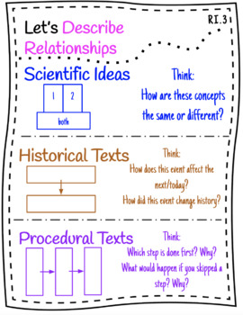
15 days | Perspectives | RL.2.6 Distinguish differences in the points of view of characters, including by speaking in a different voice for each character when reading dialogue aloud.  RI.2.6 Identify the author’s main purpose of a text, including what the author wants to answer, explain, or describe.  RI.2.7 Explain how specific images contribute to and clarify a text.  L.2.1 Demonstrate command of the conventions of standard English grammar and usage when writing or speaking; demonstrate proficiency within the 2-3 grammar continuum.  RF.2.2 Print all upper- and lowercase letters legibly and proportionallyPrint all upper- and lowercase letters legibly and proportionally.  W.2.1 Write opinion pieces in which they introduce the topic or book they are writing about, state an opinion, supply reasons that support the opinion, use linking words to connect opinion and reasons, and provide a concluding statement or section.  a. With guidance and support from adults, organize information and ideas around a topic to plan and prepare to write.  b. With guidance and support from adults and peers, focus on a topic and strengthen writing as needed by revising and editing. | RL.3.6 Distinguish their own point of view from that of the narrator or those of the characters.  RI.3.6 Distinguish their own point of view from that of the author of a text.  RI.3.5 Use text features and search tools to locate information relevant to a given topic efficiently  RI.3.7 Use information gained from illustrations and the words in a text to demonstrate understanding of the text.  L.3.1 Demonstrate command of the conventions of standard English grammar and usage when writing or speaking; demonstrate proficiency within the 2-3 grammar continuum.  Week 13: Simple verb tense  Week 14: Irregular verbs  Week 15: Pronouns  RF.3.2 Create readable documents with legible handwriting (manuscript and cursive).  Week 13: Curve Forward Letters N. M. H, K,  Week 14: Curve Forward Letters U, Y, V, W  Week 15: Curve Forward Letters Z, X  RF.3.4 Know and apply grade-level phonics and word analysis skills in decoding words.  a. Identify and know the meaning of the most common prefixes and derivational suffixes.  b. Decode words with common Latin suffixes.  W.3.1 Write opinion pieces on topics or texts, supporting a point of view with reasons.  a. Organize information and ideas around a topic to plan and prepare to write.  b. Introduce the topic or text they are writing about, state an opinion, and create an organizational structure that lists reasons.  c. Provide reasons that support the opinion.  d. Use linking words and phrases to connect opinion and reasons.  e. Provide a concluding statement or section.  f. With guidance and support from peers and adults, develop and strengthen writing as needed by revising and editing, with consideration to task and purpose. | RL.3.6  Point of view  Narrator  Distinguish  Compare  Contrast  Character  Personal  Narrator  Differ  RI.3.6  Distinguish  Point of View  Author  Informational  Text  RI.3.5  Text features  Side bars  Headings  Captions  Diagrams  Indexes  RI.3.7  Illustrations  W.3.1  Opinion  Reasons  Topic  Concluding statement  Revising  Task  Purpose  Digital sources | The Crocodile's Toothache Poem  The Crocodile Toothache Point of View Activity RL.3.6  Rethink Education Lesson Focus RI.3.5 and RI.3.7  RF.3.2 Resources  Cursive Writing  Cursive Writing  Worksheet Works (cursive practice)
15 days  Spend 2 weeks on RI3.8 and 1 week on RL3.3 as a spiral review from the 1st Nine Weeks | The Structures of Information Text | RI.2.8 Identify the reasons an author gives to support ideas in a text.  RI.2.3 Describe the connection between a series of historical events, scientific ideas or concepts, or steps in technical procedures in a text.  L.2.1 Demonstrate command of the conventions of standard English grammar and usage when writing or speaking; demonstrate proficiency within the 2-3 grammar continuum.  RF.2.2 Print all upper- and lowercase letters legibly and proportionally  W.2.5 Participate in shared research and writing projects.  W.2.6 Recall information from experiences or gather information from provided sources to answer a question. | RI.3.8  Describe how the author connects ideas between sentences and paragraphs to support specific points in a text.  RL.3.3: Describe characters in a story and explain how their actions contribute to the sequence of events.  L.3.1 Demonstrate command of the conventions of standard English grammar and usage when writing or speaking; demonstrate proficiency within the 2-3 grammar continuum.  Week 16: Possessive pronouns/apostrophe  Week 17: Commas/Friendly Letter  Week 18: Review  RF.3.2 Create readable documents with legible handwriting (manuscript and cursive).  Week 16: Double Curve letters T & F  Week 17: Review letters  SL.3.1 Engage effectively in a range of collaborative discussions (one-on-one, in groups, and teacher-led) with diverse partners on grade 3 topics and texts, building on others’ ideas and expressing their own clearly.  a. Come to discussions prepared, having read or studied required material; explicitly draw on that preparation and other information known about the topic to explore ideas under discussion.  b. Follow agreed-upon rules for discussions.  c. Ask questions to check understanding of information presented, stay on topic, and link their comments to the remarks of others.  d. Explain their own ideas and understanding in light of the discussion.  W.3.5 Conduct short research projects that build knowledge about a topic.  W.3.6 Recall information from experiences or gather information from print and digital sources; take brief notes on sources and sort evidence into provided categories. | RI.3.8  Text Structure  Cause and Effect  Description  Comparisons  Sequence  RL.3.3  Describe  Characters  Affect  Story  Sequence  Order of Events  Details  Contribute  Text | Use this anchor chart to help teach the different types of text structures we see when reading informational text. Recommendation is to choose different selections that have each text structure and expose the students to one a day the first week.  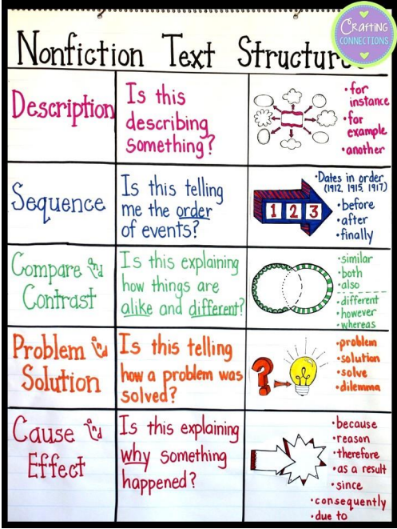  Text Structure Paragraphs
NC Check-In #2 Suggested Timeline: End of Quarter 2
Third Nine Weeks
Number  of Days | Name of Unit/Module | Pre-Requisites | Standards | Academic Vocabulary | Instructional Resources
10 days | The Lesson Characters Learn | RL.2.2 Recount stories, including fables and folktales from diverse cultures, and determine their central message, lesson, or moral.  RL.2.3 Describe how characters in a story respond to major events and challenges.  RL.2.10 By the end of grade 2, read and understand literature within the 2-3 text complexity band proficiently and independently for sustained periods of time. Connect prior knowledge and experiences to text.  L.2.1 Demonstrate command of the conventions of standard English grammar and usage when writing or speaking; demonstrate proficiency within the 2-3 grammar continuum. | RL.3.2 Recount stories, including fables, folktales, and myths from diverse cultures; determine the central message, lesson, or moral and explain how it is conveyed through key details in the text.  RL.3.3: Describe characters in a story and explain how their actions contribute to the sequence of events.  RL.3.1: Ask and answer questions to demonstrate understanding of a text, referring explicitly to the text as the basis for the answers.  RL.3.10 By the end of grade 3, read and understand literature at the high end of the 2-3 text complexity band proficiently and independently for sustained periods of time. Connect prior knowledge and experiences to text.  L.3.1 Demonstrate command of the conventions of standard English grammar and usage when writing or speaking; demonstrate proficiency within the 2-3 grammar continuum.  Week 18: Contractions  Week 19: Prepositions & Prepositional phrases  Week 20: Comparative adjectives/articles (determiners)  RF.3.2 Create readable documents with legible handwriting (manuscript and cursive).  Week 18: Undercurve Loop Letters G, S, & L  Week 19: Review letters, strokes, connectors  W.3.2: Write informative/explanatory texts to examine a topic and convey ideas and information clearly.  Introduce a topic and group related information together; include illustrations when useful to aid comprehension.  Develop the topic with facts, definitions, and details.  Use linking words and phrases (e.g., also, another, and more, but) to connect ideas within categories of information.  Provide a concluding statement or section. | RL.3.2  Support  Recount  Moral  Central Message  Explain  RL.3.3  Describe  Characters  Affect  Story  Sequence  Order of Events  Details  Contribute  Text  RL.3.1  Ask  Answer  Questions  Evidence  Explicit  Explicitly  W.3.2 Linking phrases Revision Revising Purpose Closure | The Fox and The Grapes Fable Text and Tasks  Thinking Map Templates  Poetry as Superhero Genre  RTA Grade Portfolio Released - NC DPI  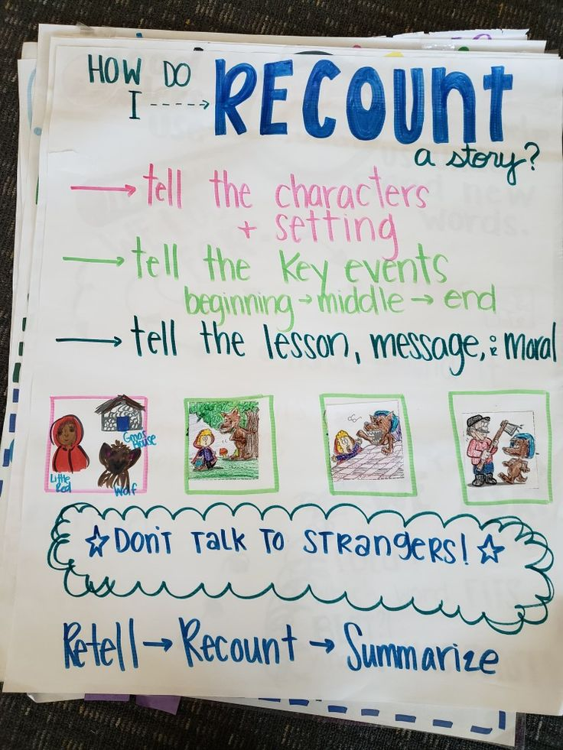
10 days | Recognizing Similarities and Differences | RI.2.1 Ask and answer such questions as who, what, where, when, why, and how to demonstrate understanding of key details in a text.  RI.2.9 Compare and contrast the most important points presented by two texts on the same topic.  RI.2.10 By the end of grade 2, read and understand informational texts within the 2-3 text complexity band proficiently and independently for sustained periods of time. Connect prior knowledge and experiences to text.  W.2.2 Write informative /explanatory texts in which they introduce a topic, use facts and definitions to develop points,  and provide a concluding statement or section.  a. With guidance and support from adults, organize information and ideas around a topic to plan and prepare  to write.  b. With guidance and support from adults and peers, focus on a topic and strengthen writing as needed by  revising and editing. | RI.3.1 Ask and answer questions to demonstrate understanding of a text, referring explicitly to the text as the basis for the answers.  RI.3.9 Compare and contrast the most important points and key details presented in two texts on the same topic.  SL.3.3 Ask and answer questions about information from a speaker, offering appropriate elaboration and detail.  L.3.4 Determine and/or clarify the meaning of unknown and multiple-meaning words and phrases based on grade 3 reading and content, choosing flexibly from a range of strategies: context clues, word parts, word relationships, and reference materials.  L.3.1 Demonstrate command of the conventions of standard English grammar and usage when writing or speaking; demonstrate proficiency within the 2-3 grammar continuum.  Week 21: Adverbs  Week 22: Complex sentences  Week 23: Pronoun-antecedent agreement  RF.3.2 Create readable documents with legible handwriting (manuscript and cursive).  Week 21-23 Practice writing signatures, words, sentences, and paragraphs.  W.3.2: Write informative/ explanatory texts to examine a topic and convey ideas and information clearly.  - Introduce a topic and group related information together; include illustrations when useful to aid comprehension.  - Develop the topic with facts, definitions, and details.  - Use linking words and phrases (e.g., also, another, and more, but) to connect ideas within categories of information.  - Provide a concluding statement or section. | RI.3.1  Ask  Answer  Questions  Informational  Text  Evidence  Explicit  Explicitly  RI.3.9  Compare  Contrast  Key details  Topic  L.3.4  Multiple meanings  Context clues  Word relationships  W.3.2 Linking phrases Revision Revising Purpose Closure | Rethink Education Lesson RI.3.9  RTA Grade Portfolio Released - NC DPI  RI3.9 ELA Sample Lesson
10 days | Words and Their Meanings | RL.2.4 Describe how words and phrases supply rhythm and meaning in a story, poem, or song.  RL.2.5 Describe the overall structure of a story, including describing how the beginning introduces the story, the events unfold in the middle, and the ending concludes the action.  RL.2.10 By the end of grade 2, read and understand literature within the 2-3 text complexity band proficiently and independently for sustained periods of time. Connect prior knowledge and experiences to text.  L.2.5 Demonstrate understanding of nuances in word meanings. a. Distinguish shades of meaning among closely related verbs and closely related adjectives. | RL.3.4 Determine the meaning of words and phrases as they are used in a text, identifying words that impact the meaning in a text.  L.3.4 Determine and/or clarify the meaning of unknown and multiple-meaning words and phrases based on grade 3 reading and content, choosing flexibly from a range of strategies: context clues, word parts, word relationships, and reference materials.  Week 24: Homophones  Week 25: Synonyms  Week 26: Antonyms  L.3.5 Demonstrate understanding of nuances in word meanings.  a. Distinguish the literal and nonliteral meanings of words and phrases in context.  b. Distinguish shades of meaning among related words that describe states of mind or degrees of certainty.  RF.3.4 Know and apply grade-level phonics and word analysis skills in decoding words.  a. Identify and know the meaning of the most common prefixes and derivational suffixes.  b. Decode words with common Latin suffixes.  W.3.2: Write informative/explanatory texts to examine a topic and convey ideas and information clearly.  - Introduce a topic and group related information together; include illustrations when useful to aid comprehension.  - Develop the topic with facts, definitions, and details.  - Use linking words and phrases (e.g., also, another, and more, but) to connect ideas within categories of information.  - Provide a concluding statement or section. | RL.3.4  Determine  Phrases  Literal  Non-Literal  Inferential  Distinguish  Figurative Language  Idioms  Simile  Metaphor  RL.3.5  Genre  Poem  Stanza  Successive  “Build upon”  Describe  L.3.4  Multiple meanings  Context clues  Word relationships  L.3.5  Literal  Nonliteral Nuances Shades of Meaning | Multiple Meaning Website - This site provides some examples of how you could teach multiple meaning words in your classroom.  RTA Grade Portfolio Released - NC DPI  L3.4 ELA Lesson Sample  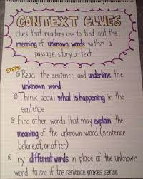
10 days | Making Connections in Informational Text | RI.2.4 Determine the meaning of words and phrases in a text relevant to a grade 2 topic or subject area.  RI.2.8 Identify the reasons an author gives to support ideas in a text  RI.2.10 By the end of grade 2, read and understand informational texts within the 2-3 text complexity band proficiently and independently for sustained periods of time. Connect prior knowledge and experiences to text.  W.2.2 Write informative /explanatory texts in which they introduce a topic, use facts and definitions to develop points,  and provide a concluding statement or section.  a. With guidance and support from adults, organize information and ideas around a topic to plan and prepare  to write.  b. With guidance and support from adults and peers, focus on a topic and strengthen writing as needed by  revising and editing. | RI.3.4 Determine the meaning of general academic and domain specific words and phrases in a text relevant to a grade 3 topic or subject area.  RI.3.8 Describe how the author connects ideas between sentences and paragraphs to support specific points in a text.  RI.3.5 Use text features and search tools to locate information relevant to a given topic efficiently.  RI.3.7 Use information gained from illustrations and the words in a text to demonstrate understanding of the text.  RI.3.10 By the end of grade 3, read and understand informational texts at the high end of the 2-3 text complexity band proficiently and independently for sustained periods of time. Connect prior knowledge and experiences to text.  SL.3.4 Report on a topic or text, tell a story, or recount an experience with appropriate facts and relevant, descriptive details, speaking clearly in complete sentences at an understandable pace.  RF.3.4 Know and apply grade-level phonics and word analysis skills in decoding words.  a. Identify and know the meaning of the most common prefixes and derivational suffixes.  b. Decode words with common Latin suffixes.  L.3.6 Acquire and use accurately grade appropriate conversational, general academic, and domain specific words and phrases, including those that signal spatial and temporal relationships.  W.3.2: Write informative/explanatory texts to examine a topic and convey ideas and information clearly.  - Introduce a topic and group related information together; include illustrations when useful to aid comprehension.  - Develop the topic with facts, definitions, and details.  - Use linking words and phrases (e.g., also, another, and more, but) to connect ideas within categories of information.  - Provide a concluding statement or section. | RI.3.4  Domain Specific Vocabulary  RI.3.8  Describe  Connection  Sentence  Paragraph  Text Structure  Informational  Text  Cause  Effect  Compare  Sequence  Description  List  W.3.2  Linking phrases Revision Revising Purpose Closure | RTA Grade Portfolio Released - NC DPI  RI3.5 Sample Lesson Plan  RF3.4 Prefixes and Suffixes
5 days | Review/Check-In #3 Suggested Timeline: At the end of unit 3.
NC Check-In #3 Suggested Timeline: End of Quarter 3
4th Nine Weeks
Number  of Days | Name of Unit/Module | Pre-Requisites | Standards | Academic Vocabulary | Instructional Resources
10 days | Getting the GIST of it | RI.2.2 Identify the main topic of a multi-paragraph text as well as the focus of specific paragraphs within the text.  RI.2.4 Determine the meaning of words and phrases in a text relevant to a grade 2 topic or subject area.  RI.2.10 By the end of grade 2, read and understand informational texts within the 2-3 text complexity band proficiently and independently for sustained periods of time. Connect prior knowledge and experiences to text.  W.2.4 With guidance and support from adults, use a variety of digital tools and resources to produce and publish writing, including in collaboration with peers. | RI.3.2 Determine the main idea of a text; recount the key details and explain how they support the main idea.  RI.3.4 Determine the meaning of general academic and domain specific words and phrases in a text relevant to a grade 3 topic or subject area.  RI.3.10 By the end of grade 3, read and understand informational texts at the high end of the 2-3 text complexity band proficiently and independently for sustained periods of time. Connect prior knowledge and experiences to text.  SL.3.2 Determine the main ideas and supporting details of a text read aloud or information presented in diverse media and formats, including visually, quantitatively, and orally.  L.3.6 Acquire and use accurately grade appropriate conversational, general academic, and domain specific words and phrases, including those that signal spatial and temporal relationships.  RF.3.4 Know and apply grade-level phonics and word analysis skills in decoding words. a. Identify and know the meaning of the most common prefixes and derivational suffixes. b. Decode words with common Latin suffixes. c. Decode multisyllabic words. d. Read grade-appropriate irregularly spelled words.  W.3.4 With guidance and support from adults, use digital tools and resources to produce and publish writing (using word processing skills) as well as to interact and collaborate with others. | RI.3.2  Determine  Main idea  Informational  Text  Identify  Key details  Supporting Details  RI.3.4  Domain Specific Vocabulary  W.3.4  Digital tools  Interact  Publish | Main Idea Lessons on Readworks  RTA Grade Portfolio Released - NC DPI  Our World and Culture Unit Study - This resource covers multiple standards.  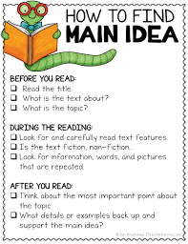
10 days | Describing Connections | RI.2.3 Describe the connection between a series of historical events, scientific ideas or concepts, or steps in technical procedures in a text.  RI.2.10 By the end of grade 2, read and understand informational texts within the 2-3 text complexity band proficiently and independently for sustained periods of time. Connect prior knowledge and experiences to text.  W.2.5 Participate in shared research and writing projects. | RI.3.3 Describe the relationship between a series of historical events, scientific ideas or concepts, or steps in technical procedures in a text, using language that pertains to time, sequence, and cause/effect.  RI.3.10 By the end of grade 3, read and understand informational texts at the high end of the 2-3 text complexity band proficiently and independently for sustained periods of time. Connect prior knowledge and experiences to text.  SL.3.5 Create engaging audio recordings of stories or poems that demonstrate fluid reading at an understandable pace; add visual displays when appropriate to emphasize or enhance certain facts or details.  L.3.3 Use knowledge of language and its conventions when writing, speaking, reading, or listening.  a. Choose words and phrases for effect.  b. Recognize and observe differences between the conventions of spoken and written standard English.  RF.3.5 Read with sufficient accuracy and fluency to support comprehension. a. Read on-level text with purpose and understanding. b. Read on-level prose and poetry orally with accuracy, appropriate rate, and expression on successive readings. c. Use context to confirm or self-correct word recognition and understanding, rereading as necessary.  W.3.5 Conduct short research projects that build knowledge about a topic. | RI.3.3  Historical  Events  Idea  Concept  Procedure  Sequence  Cause  Effect  Genre  W.3.5  Topic | RTA Grade Portfolio Released - NC DPI  RI3.3 Harriet Tubman Lesson  Suggested books to read for RI3.3  - Now and Ben by Gene Barretta  - How People Learned to Fly by Fran Hodgkins  - From Peanut to Peanut Butter by Robin Nelson  - School: Then and Now by Robin Nelson  - The Magic School Bus Gets Baked in a Cake by Joanna Cole  - From Seed to Plant by Gail Gibbons  - Hidden Figures by Margot Lee Shetterly  - This is How We Do It: One Day in the Lives of Seven Kids from Around the World by Matt Lamothe
10 days | Embracing Similarities and Differences | RL.2.9 Compare and contrast two or more versions of the same story by different authors or from different cultures.  RL.2.1 Ask and answer such questions as who, what, where, when, why, and how to demonstrate understanding of key details in a text.  RL.2.10 By the end of grade 2, read and understand literature within the 2-3 text complexity band proficiently and independently for sustained periods of time. Connect prior knowledge and experiences to text. | RL.3.9 Compare and contrast the themes, settings, and plots of stories written by the same author about the same or similar characters.  RL.3.1 Ask and answer questions to demonstrate understanding of a text, referring explicitly to the text as the basis for the answers.  RL.3.4 Determine the meaning of words and phrases as they are used in a text, identifying words that impact the meaning in a text.  RL.3.10 By the end of grade 3, read and understand literature at the high end of the 2-3 text complexity band proficiently and independently for sustained periods of time. Connect prior knowledge and experiences to text.  W.3.6 Recall information from experiences or gather information from print and digital sources; take brief notes on sources and sort evidence into provided categories. | RL.3.9  Compare  Contrast  Plot  Theme  Setting  RL.3.1  Ask  Answer  Questions  Evidence  Explicit  Explicitly  RL.3.4  Determine  Phrases  Literal  Non-Literal  Inferential  Distinguish  Figurative Language  Idioms  Simile  Metaphor | RTA Grade Portfolio Released - NC DPI  RL3.9 Lesson Compare and Contrast the characters from two books by Eve Bunting
15 days | EOG Review & EOG Testing Window (typically reserved for last 10 days of school year)
Learning Targets for First 20-25 Days of Course:

Day # | Daily Learning Target | How will the daily learning target be assessed?
1st Nine Weeks
Unit 1: Why Are Questions Important (15 days)
1 | RL.3.1: I can answer questions to show I understand important details in a story.  RF.3.3.c I can break apart words into syllable segments to help me decode words I do not know using the VC/CV pattern. | Students will use post-its or a document to respond to questions and cite evidence or to ask questions (KWL/KWHL) about the selection read.  RF.3.3c VC/CV Syllable exit ticket
2 | RL.3.1: I can ask questions to show I understand important details in a story.  RF.3.3c I can break apart words into syllable segments to help me decode words I do not know using the V/CV pattern. | QAR Question Stems RL.3.1 - Generate one question from each area of the QAR Question Stems chart from the text you are reading  RF.3.3c V/CV Syllable exit ticket
3 | RL.3.1: I can ask and answer questions before, during, and after reading a text  RF.3.3c I can break apart words into syllable segments to help me decode words I do not know using the VC/V pattern. | RL.3.1 Reading Selection with questions  Before, During and After Question and Answer Ideas  VC/C Google Slide Exit Ticket RF.3.3c
4 | RL.3.1: I can answer questions explicitly from the story.  RF.3.3c I can break apart words into syllable segments to help me decode words I do not know using the CV/VC pattern. | Answer and Evidence Chart - Use the template to have students answer a question from the information text you are reading.
5 | RL.3.1: I can reference what the text explicitly states to support my answers to questions.  RF.3.3c I can break apart words into syllable segments to help me decode words I do not know using the VCCV, V/CV, VC/V and CV/VC.. | Answer and Evidence Chart - Use the template to have students answer a question from the information text you are reading.
6 | RI.3.1: I can answer questions to show I understand the informational text.  RF.3.3c I can teach a peer my strategy(ies) for decoding multisyllabic words, through demonstration. | Editable Exit Tickets - Choose one to address a question from the text you are reading and have students answer it on your selected exit ticket.
7 | RI.3.1: I can generate questions from the informational text when reading. | QAR Question Stems RI.3.1 - Generate one question from each area of the QAR Question Stems chart from the text you are reading
8 | RI.3.1: I can ask and answer 3 or more questions to demonstrate understanding of informational text. | RI.3.1 Reading Selection with questions
9 | RI.3.1: I can answer questions explicitly from the text. | RI.3.1 Reading Selection with questions
10 | RI.3.1: I can reference what the text explicitly states to support my answers to questions. | Students will use post-its or a document to respond to questions and cite evidence or to ask questions (ie. KWL/KWHL) about the selection read.
11 | RI.3.5: I can identify and give examples of text features and search tools. | Digital Tool Identifying Text Features
12 | RI.3.5: I can explain how text features and search tools help locate information quickly and help understand what I read. | Name two text features and how they help you understand the informational text you read. Nearpod Lesson RI.3.5
13 | RI.3.5: I can locate information about a topic using text features and search tools. | Amazing Animals Video National Geographic RI.3.5  Editable Exit Tickets - Choose one from the selection and have students write which text feature they observed in the video clip above.
14 | RI.3.5: I can use headings, bold words, captions, highlighted words, etc. to find information and explain how these features help me understand the text. | Text Features - How They Support Comprehension - have students select a text feature from a nonfiction book and explain how this helps the reader understand the text.  Ex. Bold print signals important vocabulary for the reader as they read the text.
15 | RI.3.5: I can use text features to answer questions about the informational text. | Cheetah Reading Selection RI3.5
Unit 2: What’s the Big Idea? (15 days)
16 | RL.3.2:  I can recount the story with a beginning, middle, and ending. | Have students recount the details on a chart similar to this.  Beginning Middle End
17 | RL.3.2: I will recount a fable using key details from the text. | Fable Graphic Organizer RL.3.2
18 | RL.3.2:  I can identify the message/lesson/moral by using 2 - 3 details from the fable. | Fables RL.3.2 - Have students read the last fable in the selection “The Mouse at the Seashore” and complete the last part of the graphic organizer
19 | RL.3.2:  I will identify the central message or lesson of a fable and tell how it is conveyed using key details from the text.  I can describe how this lesson can be applied to my life. | Read aloud “The Boy Who Cried Wolf”. Have students answer the following questions.  - What lesson was learned by the Shepherd Boy? What is the evidence?  - How can we apply what we have learned from the fable to our own lives?
20 | RL.3.2:  I will identify the central message or lesson of a story and explain how the events support the central message. | Quizzes on Central Message RL.3.2
21 | RL.3.2:  I will recount a folktale using key details from the text. | Folktale Graphic Organizer
22 | RL.3.2:  I can identify the message/lesson/moral by using 2 - 3 details from the folktale. | How the Chipmunk Got Its Stripes Folktale RL.3.2 - Have students read the folktale, then complete the graphic organizer section about this particular folktale
23 | RL.3.2: I will identify the central message or lesson of a folktale and tell how it is conveyed using key details from the text. | Folktale passage and questions RL.3.2
24 | RL.3.2:  I will recount a myth using key details from the text. | RL.3.2 Myth
25 | RL.3.2: I will identify the central message or lesson of a myth and tell how it is conveyed using key details from the text. | King Midas and The Golden Touch Quizizz RL.3.2 After reading King Midas and the Golden Touch have the student complete the following quizizz
26 | RI.3.2:  I will identify the topic. | Main Idea bags: have students open certain bags and identify what they all have in common or the topic  Examples:  - stapler, pencil, paperclip, eraser, scissors: OFFICE SUPPLIES  - plate, utensils, napkin: THINGS YOU USE WHEN EATING  - toothbrush, toothpaste, dental floss: THINGS YOU USE TO KEEP YOUR TEETH CLEAN
27 | RI.3.2:  I will find the key details of informational text. | Have students read a short informational text. Have them use highlighters or colored pencils to underline the key details as they read.
28 | RI.3.2:  I will determine the main idea of informational text. | Main Idea Exit Ticket RI.3.2  Digital Main Idea Exit Ticket RI.3.2
29 | RI.3.2  I can connect details to the main ideas that they support. | Main Idea Graphic Organizer RI.3.2
30 | RI.3.2:  I can tell the difference between the main idea and details of a text. | Main Idea Passage RI.3.2
Unit 3: Characters: What or Who Keeps the Story Going? (10 days)
31 | RL ..3: I can identify common character traits. | Character Trait Identification
32 | RL.3.3: I can describe characters in a story. | Character Map RL.3.3
33 | RL.3.3:  I can explain traits about each character that help me know which character is being described.  I will describe the characters in a story (traits, motivations, feelings). | Digital Character Trait Exit Ticket RL.3.3
34 | RL.3.3:  I can explain the characters' actions and how these actions contribute to the sequence of the story. | Character Change Exit Ticket RL.3.3
35 | RL.3.3: I will explain how a character's actions contribute to the events in the story. | Character Map RL.3.3
36 | RL.3.3: I can identify a character's traits based on their actions, motives, feelings and thoughts. | Character Motivation Map
37 | RL.3.4: I can use strategies (eg., context clues, root words, affixes) to determine the meaning of words and phrases as they are used in a text. | Context Clues RL.3.4
38 | RL.3.4: I can identify literal language and nonliteral language. | Literal vs Nonliteral phrases
39 | RL.3.4: I can distinguish between literal and nonliteral language in a text. | After reading the text Amelia Bedelia, have students complete one of the phrases on this resource. Literal vs Nonliteral Amelia Bedelia
40 | RL.3.4: I can use context clues to determine the meaning of literal and nonliteral language. | Have the students choose 1 or 2 task cards and use context clues to identify the meaning.
Day # | Daily Learning Target | How will the daily learning target be assessed?
2nd Nine Weeks
Unit 4: Let’s Get Connected (15 days)
1 | RI.3.3 I can determine if the selection is a historical, scientific or technical (procedural) text and answer questions related to each text. | RI.3.3 Exit Tickets
2 | RI.3.3 I can describe the historical events, scientific ideas, or steps in procedures using words to show the sequence. | How to Text RI.3.3
3 | RI.3.3 I can tell about the time, sequence, the cause and effect of an historical event. | Historical Text RI.3.3
4 | RI.3.3 I can tell about the time, sequence, the cause and effect of an historical event. | Series of events RI.3.3
5 | RI.3.3 I can tell about the time, sequence, the cause and effect of scientific ideas | Scientific Text RI.3.3
6 | RI.3.3 I can tell about the time, sequence, the cause and effect of scientific ideas | Bees and Ants Scientific Text RI3.3
7 | RI.3.3 I can use language that shows time, sequence, and cause and effect when describing a text. | Cause and Effect Selection
8 | RI.3.3 I can use language that shows time, sequence, and cause and effect when describing a text. | Cause and Effect Graphic Organizer Read a selection and have students capture the cause and effect relationship from the text on the graphic organizer
9 | L.3.5.a I can explain the difference between literal meaning and nonliteral meaning of words and phrases. | List 4 statements on the board. Two which are literal and two that are nonliteral. Have students make a t-chart and write the phrase under the correct area.  I am so hungry.  I could eat a horse.  I slept really well last night.  I slept like a log.  Nonliteral Literal
10 | L.3.5.a I can recognize when an author's words and phrases are literal or nonliteral. | Literal and Nonliteral language L3.5a
11 | L3.5 b I can identify common synonyms that convey shades of meaning. | Have students write down two synonyms to demonstrate shades of meaning  walk strut  large gigantic
12 | L3.5 c I can show the shades of meanings of related words | 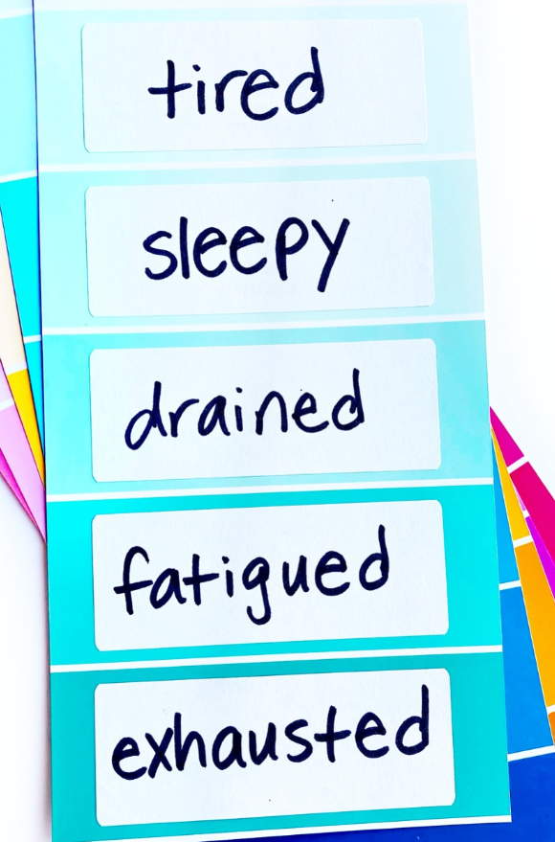  Get paint strips from the local paint store. Have students tier the words on the paint strip demonstrating the shades of meaning.
13 | RL.3.5 I can explain how stories, dramas, and poems are written in different forms (eg., section chapter, scene, or stanza. | After reading a selection, have students write how they know whether the text is a poem, drama, or stories  Ex. The selection is a poem because it is broken into stanzas.
14 | RL.3.5 I can use the terms: chapter, scene, and/or stanza correctly when writing or speaking about parts of a text. | Have the students read a drama and explain how they know it is a drama.  Ex. The selection is a drama because I see that it has scenes, cast, etc.
15 | RL.3.5 I can write and talk about fiction by using the words for the different parts (eg., chapter, scene, stanza). | Reader's Theater Script RL.3.5 After reading the reader’s theater, have the students answer the questions related to the script.
Unit 5: Perspective (15 days)
16 | RL.3.6 I can define point of view (in a story, drama, poem). | Have students write what point of view means. Have students answer the following from a selected passage of your choice.  How does the character feel about ___?
17 | RL.3.6 I can distinguish between a narrator's point of view and my own. | The character felt ___ when ___ happened. Do you think you would have felt the same way? How would you have reacted?
18 | RL.3.6 Distinguish their own point of view from that of the narrator or those of the characters. | RL.3.6 Exit Ticket
19 | RL.3.6 Distinguish their own point of view from that of the narrator or those of the characters. | No Homework Point of View
20 | RI.3.6 I can define point of view (in an informational text). | What is the author’s opinion about __?
21 | RI.3.6 .I can determine the point of view of the author (in an informational text). | Point of View Sentences
22 | RI.3.6 I can identify and describe how my point of view is similar to or different from the author. | The author feels ___ about ___. Do you agree or disagree with the author’s point of view?  Point of View Exit Ticket
23 | RI.3.6 Distinguish their own point of view from that of the author of a text. | RI.3.6 POV Graphic Organizer
24 | RI.3.6 Distinguish their own point of view from that of the author of a text. | Titanic Point of View
25 | RI.3.5 Use text features and search tools to locate information relevant to a given topic efficiently. | After reading an informational text, have the students create an illustration and create a caption for the illustration. Caption Illustration
26 | RI.3.5 Use text features and search tools to locate information relevant to a given topic efficiently. | Over the next 3 days to 5 days have the students complete one section a day on this project to assess their understanding of Nonfiction Text Features All About Me Nonfiction Features
27 | RI.3.5 Use text features and search tools to locate information relevant to a given topic efficiently. | Over the next 2 days have the students complete one section a day on this project to assess their understanding of Nonfiction Text Features All About Me Nonfiction Features
28 | RI.3.7 Use information gained from illustrations and the words in a text to demonstrate understanding of the text. | Have the students complete one section a day on this project to assess their understanding of Nonfiction Text Features All About Me Nonfiction Features
29 | RI.3.7 Use information gained from illustrations and the words in a text to demonstrate understanding of the text. | Wild Weather Text RI.3.7
30 | RI.3.7 Use information gained from illustrations and the words in a text to demonstrate understanding of the text. | RI.3.7 text  RI.3.7 text answer key
Unit 6: The Structures of Information Text (15 days)
31 | RI.3.8 I can describe how the sentences and paragraphs in informational text are connected and follow a logical order. | Cut apart three to five sentence strips with events from a historical event or steps to make or build an object. Students will arrange the strips in the correct order. After they have selected the sequence, have them explain/defend the sequence.
32 | RI.3.8 I can describe how the sentences and paragraphs in informational text are connected and follow a logical order. | RI.3.8 FCRR Sequence
33 | RI.3.8 I can describe how the author connects ideas between sentences and paragraphs to support specific points in a text. | RI.3.8 The Important Thing Students will read a selected text and complete page13.
34 | RI.3.8 I can understand comparison relationships of informational texts. | RI.3.8 Comparison Exit Ticket  Students will read the selection and complete the guiding questions.
35 | RI.3.8 I can understand comparison relationships of informational texts. | RI.3.8 Comparison Exit Ticket Students will reread the selection and compare ice cream and soft serve using a Venn diagram (page 4).
36 | RI.3.8 I can understand cause and effect relationships of informational texts. | Students create a T-chart with cause at the top of one column and effect on the other.  - As they read an informational text on a subject such as a scientific discovery or an historical event, students will point out cause and effect relationships.
37 | RI.3.8 I can understand cause and effect relationships of informational texts. | RI.3.8 Safe Ride? Questions 1, 2
38 | RI.3.8 I can identify facts and details the author has cited as evidence to support his/her points. | RI.3.8 The Iguaçu River Questions 1, 2, 3, 4, 8
39 | RI.3.8 I can identify facts and details the author has cited as evidence to support his/her points. | Use this organizer to write an author’s idea, a supporting reason, and two points of supporting evidence.  Author’s Point: (“I think the author’s point is…”)  Reason: (“This is the author’s point because…”)  Evidence:  Evidence:
40 | RL.3.3 I can describe characters by citing their traits, motivations, and emotions. | RL.3.3 Character Characteristic Students will describe a character from their reading selection.
41 | RL.3.3 I can describe characters by citing their traits, motivations, and emotions. | RL.3.3 Nurse Betty
42 | RL.3.3 I can explain how the characters’ actions contribute to major and minor events of the story. | Students will read a short text of teacher’s choice and complete the character’s feelings flow chart organizer (pages 132-133).
43 | RL.3.3 I can explain how the characters’ actions contribute to major and minor events of the story. | Students will complete a character trait map (pages 123-125) to justify responses from details of the text.
44 | RL.3.3 Describe characters in a story and explain how their actions contribute to the sequence of events. | RL.3.3 Spelling Test Nightmare Students will complete page 2 after reading the selection.
45 | RL.3.3 Describe characters in a story and explain how their actions contribute to the sequence of events. | RL.3.3 The Closet Creature Students will complete page 5 after reading the selection.

Day # | Daily Learning Target | How will the daily learning target be assessed?
3rd Nine Weeks
Unit 7: The Lesson Characters Learn (10 days)
1 | RL.3.2 I can recount stories, including fables, folktales, and myths from diverse cultures. | RL.3.2 Fairy Tale Link Students will use this log to recount story elements of a fairy tale read in class.
2 | RL.3.2 I can determine the central message, lesson, or moral and explain how it is conveyed through key details in the text. | The Donkey, the Fox, and the Lion
3 | RL.3.3 I can describe characters in a story and explain how their actions contribute to the sequence of events. | RL.3.3 The Proud Boy
4 | RL.3.3 I can describe characters in a story and explain how their actions contribute to the sequence of events. | RL.3.3 Story Elements
5 | RL 3.1: I can ask questions to show I understand important details in a story. | RL.3.1 Quizizz Inferences
6 | RL 3.1: I can ask and answer questions before, during, and after reading a text. | RL.3.1 On Target Questions Students will read a selected text and write the title in the middle. Use the subheadings to write four questions in the inner ring. Make sure to choose a selection with headings and subheadings for this activity.
7 | RL 3.1: I can answer questions explicitly from the story. | RL.3.1 On Target Questions Continued from Day 6→ The students will re-read the prior day’s selection and write the answers to their questions in the outer ring.
8 | RL 3.1: I can reference what the text explicitly states to support my answers to questions. | RL.3.1 Forming Inferences
9 | RL.3.10 I can read and understand 3rd grade literature. | 3-2-1: Have students write three key terms from what they have just learned, two ideas they would like to learn more about, and one concept or skill they think they have mastered.
10 | RL.3.10 I can connect prior knowledge and experiences to text. | RL.3.10 Jason's Stomach
Unit 8: Recognizing Similarities and Differences (10 days)
11 | RI3.1 I can answer questions that demonstrate understanding such as who, what, when, where and why while referring to text for answers. | Teachers will ask one or two key questions at the conclusion of a reading activity. Responses will be based on information from the text.  Question Answer with Supporting Details From Text  1.  2.
12 | RI3.1 I can ask and find the answers to specific questions within the informational text that I read. | RI.3.1 Ask/Answer Questions Students will write two questions about an assigned topic. Students will read a variety of informational passages/text on the topic and answer their questions.
13 | RI3.1 I can ask and answer questions to demonstrate understanding of a text. | RI.3.1 KWL Chart Students will write what they know, wonder (ask questions), and learn from a selected informational text.
14 | RI3.1 I can refer explicitly to the text as the basis for the answers. | Have students make a T-chart to ask and answer questions and demonstrate understanding of key details in a text. List questions before, reading a passage on the left side, and record answers or information learned on the right side.
15 | RI3.1 I can refer explicitly to the text as the basis for the answers. | RI.3.1 Kahoot!
16 | RI3.9 I can compare and contrast the most important points and key details presented in two texts on the same topic. | RI.3.9 Compare/Contrast Two Texts Students will read two texts on the same topic and complete the graphic organizer of your choice.
17 | RI3.9 I can compare and contrast the most important points and key details presented in two texts on the same event. | Students read two texts about the same event from different points of view. Students will use a compare and contrast chart to record five or more details that are the same in both texts and at least five details that are different. Venn Diagram
18 | RI3.9 I can use note-taking to help keep track of key details and important points in a text. | Students will create a diagram of the key details from two texts on the same topic. In the diagram they indicate key ideas in the center, and then along the sides address the details from each text.
19 | RI3.9 I can compare and contrast the most important ideas and details in two pieces of information about the same topic. | Pose the DOK 3 question from the selected text of your choice→ Using text evidence, what conclusions can you make about the way the topic is presented in these texts?
20 | RI3.9 I can compare and contrast the most important points and key details presented in two texts on the same character.. | RI.3.9 Compare/Contrast Students will choose a text that has at least two characters. The student will compare and contrast two characters by listing similarities and differences between the two characters.
Unit 9: Words and Their Meanings (10 days)
21 | RL.3.4 I can figure out the meanings of words or groups of words in stories by thinking about how they are used. | RL.3.4 Context Clues
22 | RL.3.4 I can figure out the meanings of words or groups of words in stories by thinking about how they are used. | RL.3.4 Finding the Meaning
23 | RL.3.4 I can determine the meaning of words and phrases as they are used in a text. | Students re-read from a text where the teacher has underlined vocabulary words.  - They will highlight where they feel the information is found to determine the meaning of the word, by strategies such as a literal definition, a synonym, antonym, or a less direct, non-literal approach.
24 | RL.3.4 I can tell the difference between literal and nonliteral language when I read. | RL.3.4 Literal vs. Nonliteral Worksheet
25 | L.3.4 I can determine the meaning of multiple-meaning words and phrases based on grade 3 reading and content, choosing flexibly from a range of strategies: context clues, word parts, word relationships, and reference materials. | L.3.4 Words in Context The student will identify words that have multiple meanings in context.
26 | L.3.4 I can determine the meaning of multiple-meaning words and phrases based on grade 3 reading and content, choosing flexibly from a range of strategies: context clues, word parts, word relationships, and reference materials. | Give students 1-2 words from a pre-selected text. They will complete a Frayer model to demonstrate their understanding of the words.  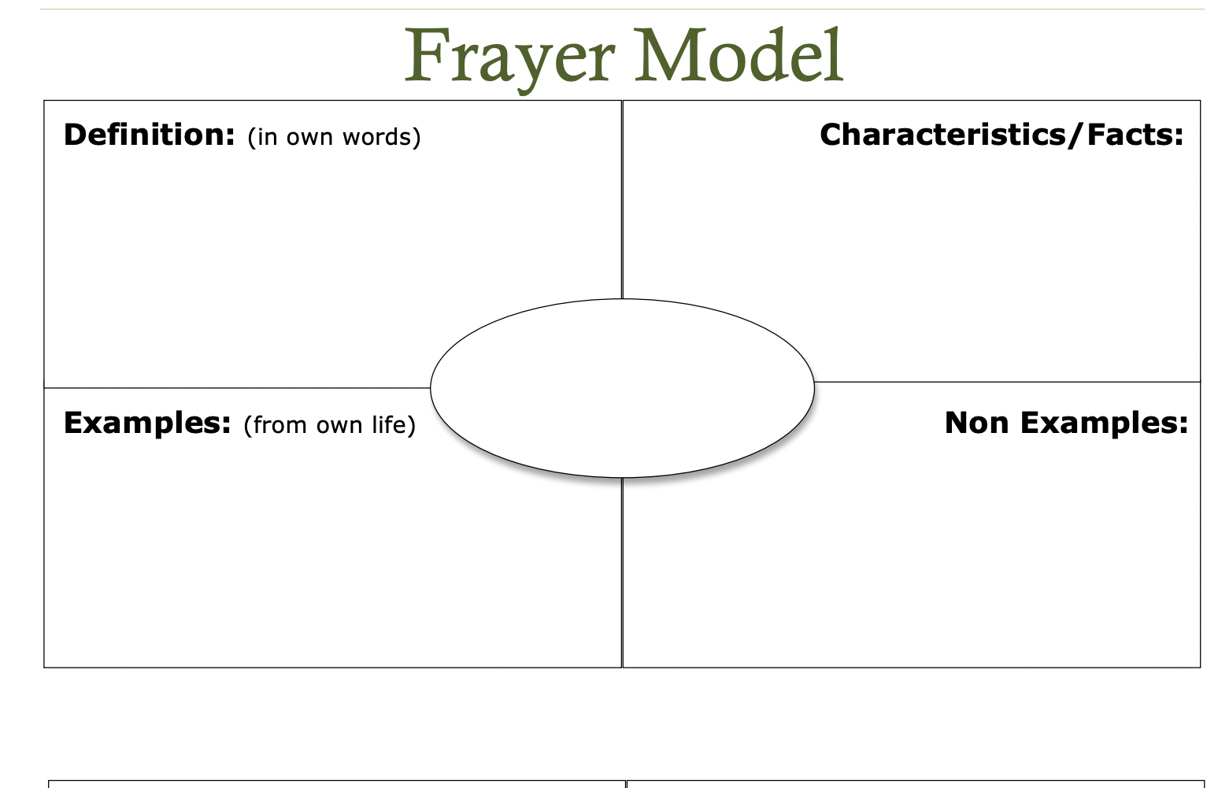
27 | RL.3.4 I can identify words that impact the meaning in a text. | The students will re-read the selected text, underline 2-3 unknown words and write the underlined words on the student sheet. The students will record the meaning of the underlined words.
28 | RL.3.4 I can identify words that impact the meaning in a text. | After reading the text, students create note cards for the targeted words with a personal definition.  - After the definition, students make notes of what words or phrases in the assigned text lead them to this definition. (Allow for prior knowledge and familiar root word recognition).
29 | RL.3.4 I can tell the difference between literal and nonliteral language when I read. | RL.3.4 Paul Bunyan--Hyperboles Students will underline the hyperboles in the selected text.
30 | RL.3.4 I can tell the difference between literal and nonliteral language when I read. | Provide a reading passage that contains examples of nonliteral language. Have students identify the nonliteral examples and determine their literal meanings.
Unit 10: Making Connections in Informational Text (10 days)
31 | RI3.4 I can determine the meaning of general academic and domain specific words and phrases in a text relevant to a grade 3 topic or subject area. | RL.3.4 The Crab The students will re-read the selection and complete page 2 for the exit ticket.
32 | RI3.4 I can determine the meaning of general academic and domain specific words and phrases in a text relevant to a grade 3 topic or subject area. | Give each student a blank Seeing Is Believing graphic organizer to complete.
33 | RI.3.8 I can describe how the author connects ideas between sentences and paragraphs to support specific points in a text. | RI.3.8 Cactus Jam Students will complete questions 1-4.
34 | RI.3.8 I can describe how the author connects ideas between sentences and paragraphs to support specific points in a text. | RI.3.8 Cactus Jam Students will complete questions 5-6.
35 | RI.3.5 I can use text features and search tools to locate information relevant to a given topic efficiently. | RI.3.5 Text Feature Chart
36 | RI.3.5 I can use text features and search tools to locate information relevant to a given topic efficiently. | RI.3.5 Text Feature Scavenger Hunt Students will use the chart to tally the text features found in the book or magazine.
37 | RI.3.7 I can use information gained from illustrations and the words in a text to demonstrate understanding of the text. | RI.3.7 News Hound Summary Students will read a news article or magazine carefully and become “news hounds”. They will be looking for who, what, when, where, why, and how the events happened and record them on the graphic organizer.
38 | RI.3.7 I can use information gained from illustrations and the words in a text to demonstrate understanding of the text. | RI.3.7 The Seasons Questions 1 - 4
39 | RL.3.10 I can read and understand 3rd grade literature. | RL.3.10 Show-U-Know Students will read a selected text/passage and complete the chart as they read to demonstrate their knowledge of 3rd grade literature.
40 | RL.3.10 I can connect prior knowledge and experiences to text. | RL.3.10 The Broken Pastry Students will highlight the supporting details from text for their answers.
Review/Check-In #3 (5 days)
41-45 | Review/check in at the end of unit 3. | Spiral Reviews.

Day # | Daily Learning Target | How will the daily learning target be assessed?
4th Nine Weeks
Unit 11: Getting the GIST of it (10 days)
1 | RI3.2 I can determine the main idea of a text. | RI.3.2 Main Idea
2 | RI3.2 I can talk about the most important details in the information I read and how they support the main idea. | RI.3.2 Supporting Details
3 | RI3.2 I can recount the key details and explain how they support the main idea. | RI.3.2 Main Idea Students will re-read a selection from class and complete the organizer.
4 | RI3.2 I can explain how the key details support the main idea. | RI.3.2 Quizizz--Main Idea
5 | RI3.4 I can determine the meaning of general academic and domain specific words and phrases in a text relevant to a grade 3 topic or subject area. | The teacher will give students a word bank with academic words from a selected text that they can choose from to complete the sentences.
6 | RI3.4 I can determine the meaning of general academic and domain specific words and phrases in a text relevant to a grade 3 topic or subject area. | RI.3.4 Science of Breath
7 | RI3.4 I can figure out the meanings of words and phrases in science and social studies texts. | RI.3.4 Assessment
8 | RL 3.1: I can reference what the text explicitly states to support my answers to questions. | RL.3.1 Students will use a selected text to answer the following DOK questions.  DOK Questions Answer  1. Who are the characters in (this story)?  2. Can you explain why (that event) happened in the story?  3. Can you predict what would have happened if ------?  4. If ------ would have happened, how would the ending of the story change?
9 | RL.3.10 I can read and understand 3rd grade literature. | RL.3.10 Show-U-Know Students will read a selection and complete the chart as they read to demonstrate their knowledge of 3rd grade literature.
10 | RL.3.10 I can connect prior knowledge and experiences to text. | RL.3.10 Carnival Week
Unit 12: Describing Connections (10 days)
11 | RI.3.3 I can describe the historical events, scientific ideas, or steps in procedures using words to show the sequence. | RI.3.3. Sequence Students will answer the questions after reading the selection.
12 | RI.3.3 I can describe the historical events, scientific ideas, or steps in procedures using words to show the sequence. | RI.3.3. Sequence Students will re-read the selection to write steps in sequential order.
13 | RI.3.3 I can use language of cause and effect. | RI.3.3 What Happened?
14 | RI.3.3 I can understand a “series of events” and “steps in a procedure” of scientific ideas. | The students will read a procedural science text. The students will list the procedures in order on sticky notes.They will then write a narrative summary using transition vocabulary such as first, next, then and finally.
15 | RI.3.3 I can use language that shows time, sequence, and cause and effect when describing a text. | RI.3.3 Cause-Effect Exit Ticket Students will highlight signal words in the text to help answer the questions.
16 | RI3.3 I can describe the relationship between a series of historical events, scientific ideas or concepts, or steps in technical procedures in a text, using language that pertains to time, sequence, and cause/effect. | RI.3.3 The Three Wishes The scholars will read the selection and answer the questions.
17 | RL.3.10 I can read and understand 3rd grade literature. | RL.3.10 The Cat and the Canary
18 | RL.3.10 I can read and understand 3rd grade literature. | RL.3.10 Poetic Peace Map See directions on page 147.
19 | RL.3.10 I can connect prior knowledge and experiences to text. | RL.3.10 Poetic Reflections See directions on page 149.
20 | RL.3.10 I can connect prior knowledge and experiences to text. | RL.3.10 The Cow
Unit 13: Embracing Similarities and Differences (10 days)
21 | RL3.9 I can compare and contrast the themes, settings, and plots of stories written by the same author about the same or similar characters. | The students will use a thinking map to sort the story elements of a story written by the same author about the same or similar character.
22 | RL3.9 I can compare and contrast the themes, settings, and plots of stories written by the same author about the same or similar characters. | The students will read two stories written by the same author. They will complete the chart by comparing and contrasting the story elements of the two stories.
23 | RL3.9 I can recognize how a character remains the same and changes in different stories or books by the same author. | RL.3.9 Character Concepts Students will complete the chart as they read a selection. Question: How did the character change in different stories from beginning, middle, and the end?
24 | RL 3.1: I can ask and answer questions before, during, and after reading a text. | RI.3.1 KWL Chart Students will write what they know (before), wonder (during), and learn (after) from a selected informational text.
25 | RL 3.1: I can answer questions explicitly from the story. | The teacher will provide two key questions at the conclusion of the reading. The students’ responses will be based on information from the text.
26 | RL 3.1: I can reference what the text explicitly states to support my answers to questions. | RL.3.1 Quiz
27 | RL3.4 I can determine the meaning of words and phrases as they are used in a text, identifying words that impact the meaning in a text. | Identify Word Use:  What does the word ____________ mean in this sentence…?  What strategies can you use to help you find the meaning of the word…?
28 | RL3.4 I can determine the meaning of words and phrases as they are used in a text, identifying words that impact the meaning in a text. | The students will record the word and the two meanings. They will use the word in a sentence.  Multiple Meaning Word Definitions Use it in a sentence  Meaning #1 Sentence  Meaning #2 Sentence
29 | RL.3.10 I can read and understand 3rd grade literature. | Students will fill out a graphic organizer with the main idea of a selected text along with 2 details from the beginning, middle, AND end of the selection.
30 | RL.3.10 I can connect prior knowledge and experiences to text. | Students will complete a summary of a selected literature text using the 5-finger (5Ws) method. The summary should include details from the beginning, middle, and end of the text.  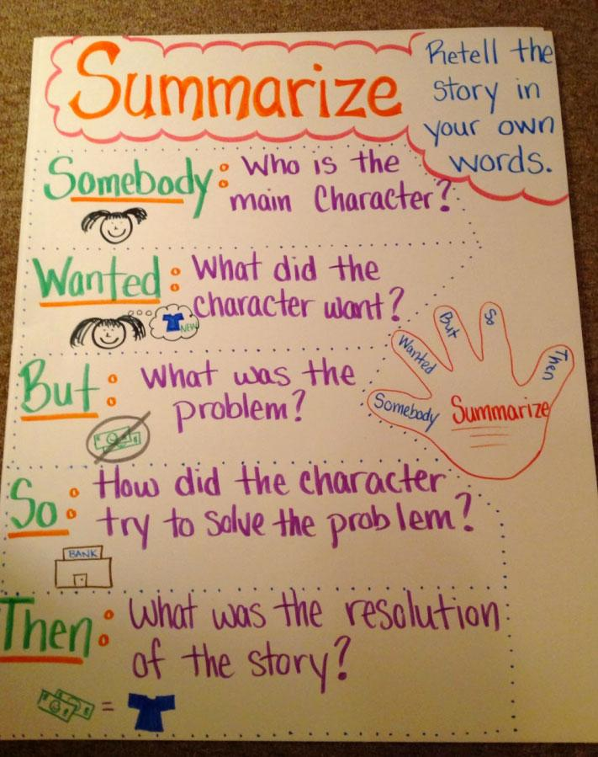
EOG Review & EOG Testing Window (typically reserved for last 10 days of school year)
31-45 | Review for EOG  Learning targets for review days may vary depending upon student needs. It is best practice to personalize learning targets for student groups based on data. | 3rd Grade Released Reading EOG

