***REGLAS Y POLÍTICAS DE LA CLASE***

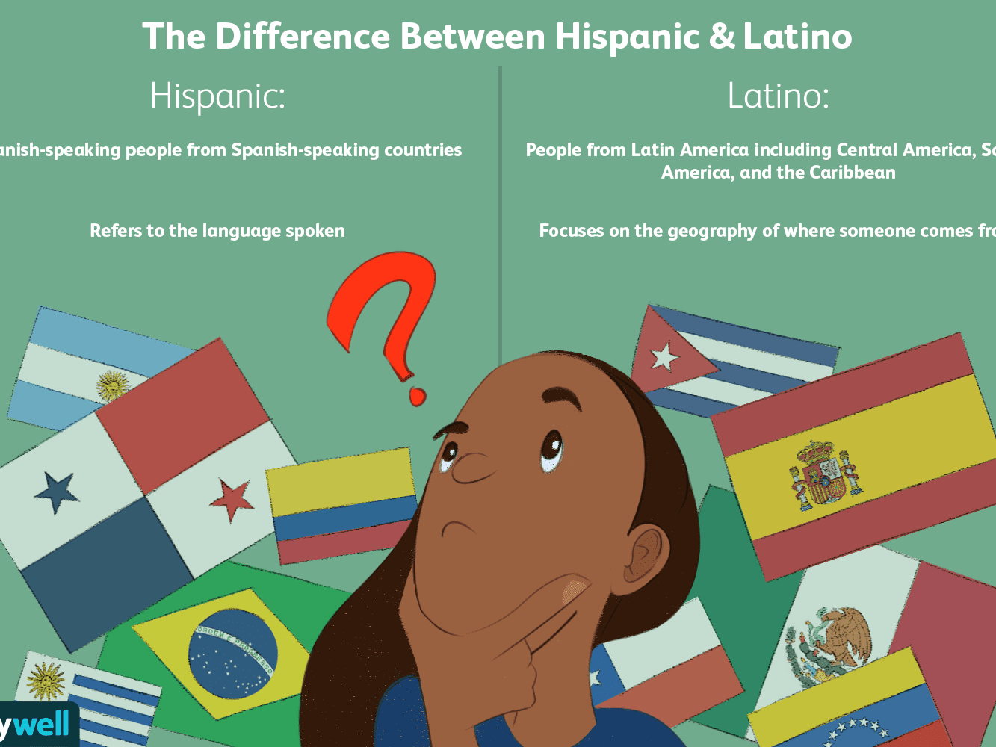

**COURSES DESCRIPTION GOALS:** Bienvenidos a la clase de Español! This year you are going to learn how to communicate in Spanish about yourself and the culture!

* **Communication:** You will develop all modes and skills of language-listening, reading, speaking and writing- at the specific proficiency level. It is all about communication, not perfection.
* **Culture:** There is a lot going on out there in the world, knowing more about the products, practices and perspectives from different Spanish speaking cultures will help you to understand and connect with others. Also, you will make comparisons and reflect on your own culture
* **Communities:** Spanish is being used all around us. Part of your out of class work will include getting into the community, and experiencing the language and culture in action. Also, you will make connections to the world, other content and careers.

**Classroom Procedures:** 

1. Enter organized, and have needed materials with you, and be prepared to learn

2. Place completed homework in Google classroom or hand it to the teacher.

3. Begin the warm-up activity posted on the board and write the date.

* + - 1. **PROCEDURES AND CONSEQUENCES**: These are the following rules you are expected to follow in and out of the class during the entire school year. When a student does not follow the rules he/she will accept the consequences. It is the student’s choice to or not to follow them.
  1. **BE HONEST**: I have a great deal for all my students. I will recognize you as a well behaved student, responsible and dedicated; unless you prove me wrong by lying, copying or forging which is unacceptable and it will bring **consequences** such as, zero on the assignment which will involve Mr. Osorio, your parents or guardian and school administration. Cheating is not tolerated at any moment.

* 1. **BE RESPECTFUL**: You should be respectful to yourself, your classmates, your teachers, staff and faculty, as well as the school or anyone else’s property. For example, books, laptops, etc. These disrespectful actions will bring the following **consequences**such as, offer a public apology to those offended, working towards a solution to the problem, and correcting the behavior. If the problem cannot be resolved by those involved, then parents will be notified, school administration and counselors will be involved “please be respectful with yourself and others”.

* 1. **BE PREPARED**: As stated in the Policies and Procedures school handout, being online or in person class is imperative. You must complete your daily homework assignments and come to class ready to participate. You must also be prepared for all tests, quizzes and graded assignments. If you are not prepared the consequences will be the following: you will receive a zero for any incomplete assignments, the whole average of the course will reflect a lower score and the loss of participation points for specific action. Finally, you should be prepared for every class otherwise, you will have troubles with the subject.

* 1. **BE RESPONSIBLE**: You are expected to retrieve any missing assignment, tests and quizzes for class, having only 1 day to make up all the work or test upon to the next online/ in person class, but if you are not in the class for any circumstances for more than two days or you have a doctor note, you have to talk to ME about the make-up work – (phone Call-Email-Google classroom).

 After an excused absence, you will schedule a time to make up any missing quiz, test or project assignment as soon as you return. This is your responsibility; I will not hunt you down to tell you what you have missed.

If you miss a test or quiz, you will have to arrange with me a time to take it (not classes hours- lunch time will be perfect) In order to make-up any test, quiz or homework, your parent or guardian MUST excuse you by sending a note with their own handwriting which will include signature and home and cellphone number on service, otherwise this will not be considered an excuse and it will not be cleared. Grooming and running errands for parents are NOT excuses and will not be honored.

If you are not responsible, you will get a zero in any homework, test or quiz not submitted to the Spanish teacher during the allotted time. You have one additional day per every two days of excused and cleared absences. Another cause to receive a zero in any other test, quiz, etc. in Spanish will happen when you do not make up the assignments within the two allotted days for the excused absence. Finally, it will cause you the loss of the full credit of your make up opportunities in the class.

* **For the Spanish class** you will need the following materials: Spanish- English dictionary, color pencils, pencils, line paper, electronic device, and 3 ring inches’ binder.
* **RULES:**

1. Do not eat food, drink, or chew gum during the class.
2. No Cell Phone unless you are allowed to use it.
3. Do ALL the homework.
4. For girls, “no cosmetics used during the class. For boys, no grooming in the class.
5. Be POLITE all the time.
6. Ask your teacher and classmates’ questions in a respectful way when you are participating in class
7. Do not use profanity. (Referral will be given).
8. Raise your hand to be recognized when you give an opinion or ask any question in class.

**During the class:**

1. No talking when the teacher is giving instructions, during tests, or when a classmate is giving a presentation/report.

3. During instructional time, nobody is permitted to leave…only during work time.

**Grading System:**

* **A 90-100**
* **B 80-89**
* **C 70-79**
* **D 60-69**
* **F 59 and below**

**Halifax County Schools High School Grading Percentages (Per Semester)**

1. Homework/Project (PBL) = 10% ( Practice)
2. Classwork = 35% (Bell Ringer Activities,Guided and Independent Work, Research Process, Note-taking and skills Based Exercises
3. Assessments (tests & projects) = 55% (Common Formative Assessments, tests/quizzes and Projects
4. Note: High school distribution is tentative because we have to factor in the Graduation Project.

* Classwork (Do Now, Labs/Group Collaboration, Participation/Behavior) - 35%
* Homework (Journals, Notes, Notebook Binder) - 15%
* Assessments (Unit, Midterm/Benchmark, Tests, Quizzes) - 50%

**Ronny Osorio-Lopez**

**Spanish I-II teacher**